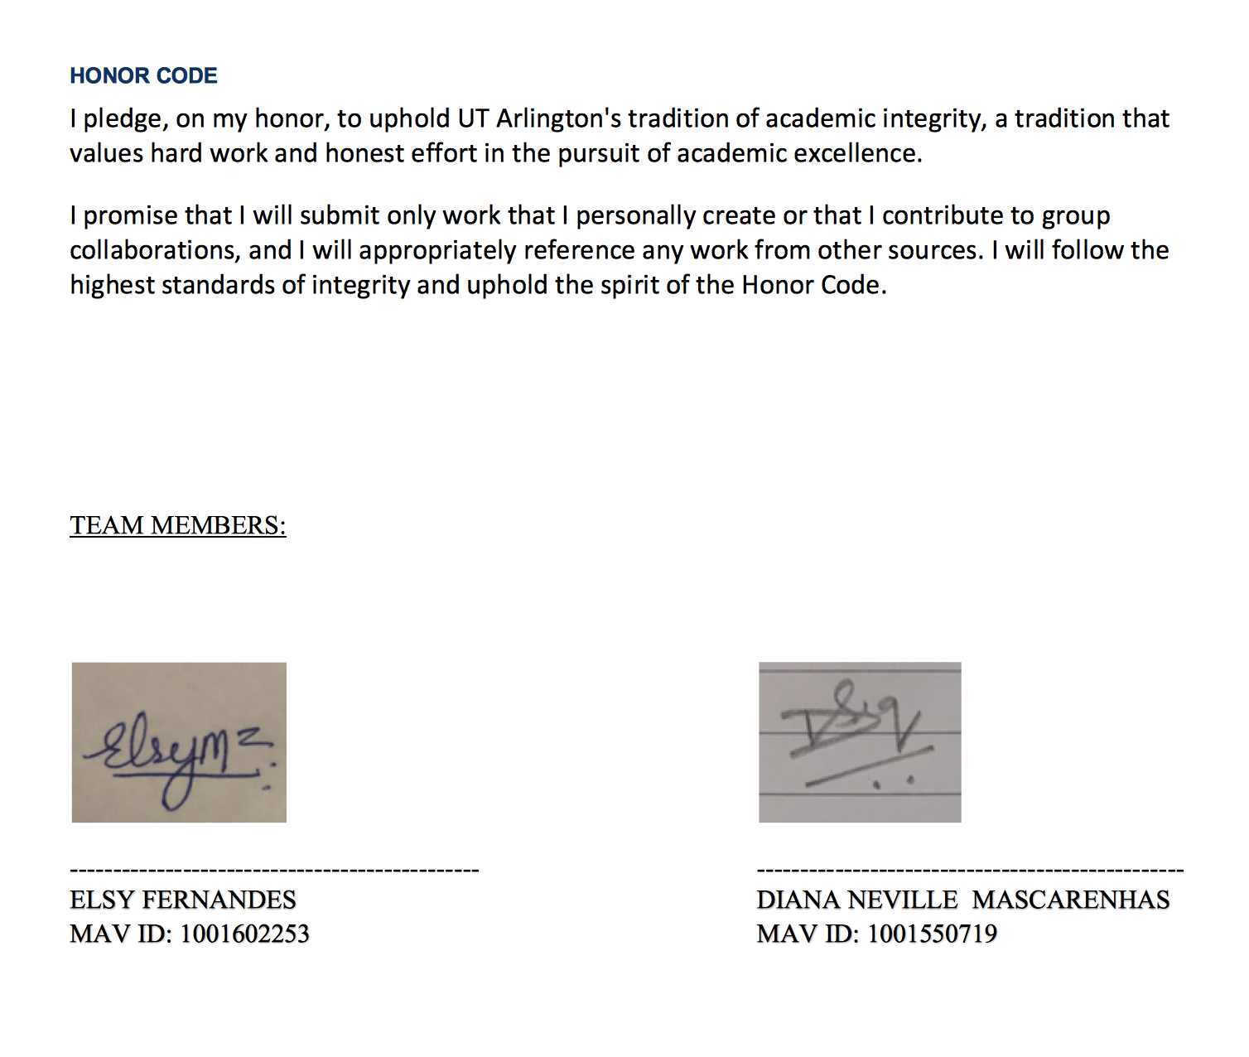

INSTRUCTIONS TO LOAD THE FILE: -

We have imported files using 3 ways (We have tested and attached the screenshots for all 3): -

* SQL import,
* importing csv files using Load command,
* Importing txt files using Load Commands.

1.In the zip folder **load_local_text_data.sql** will allow you to load the text files. We have a text file folder **worldcup_2019.** The location we have used is **Users/el/Desktop/dbfiles/Final/worldcup_2019/world-cup-teams-text.txt' (the same location is configured in our SQL file. Please change the respective table name)**

Reference with screenshots: - **load_local_text_data.docx**

2.In the zip folder **load_local_csv.sql** will allow you to load the csv files. We have a csv file folder **CSV_FILES.** The location we have used is **/Users/el/Desktop/dbfiles/Final/CSV_FILES/TEAM.csv' (the same location is configured in our SQL file. Please change the respective table name).**

Reference with screenshots**: - load_local_csv.docx**

3. Loading files using Import

Reference: - **DATA_LOAD_USING_IMPORT.docx**

Create statements**: -** **Create_Statements.sql**

**4.** SQL Queries: - **All Queries.sql**

**Note: -** Table OWN_GOALS has a foreign key (for_TeamId) constraint referencing TeamId of table TEAM. This works fine when importing files to sql without any load commands (3. Loading files using Import) ..but it fails when we load csv/text file using LOAD INFILE COMMAND.so we have commented it out while loading the files using LOAD INFILE.

**Query 1:** Retrieve the country, height, and names of all the players who hail from the African continent and are taller than 190 cm. Sort the list by country and their height.

**Solution: 15 Rows Returned**

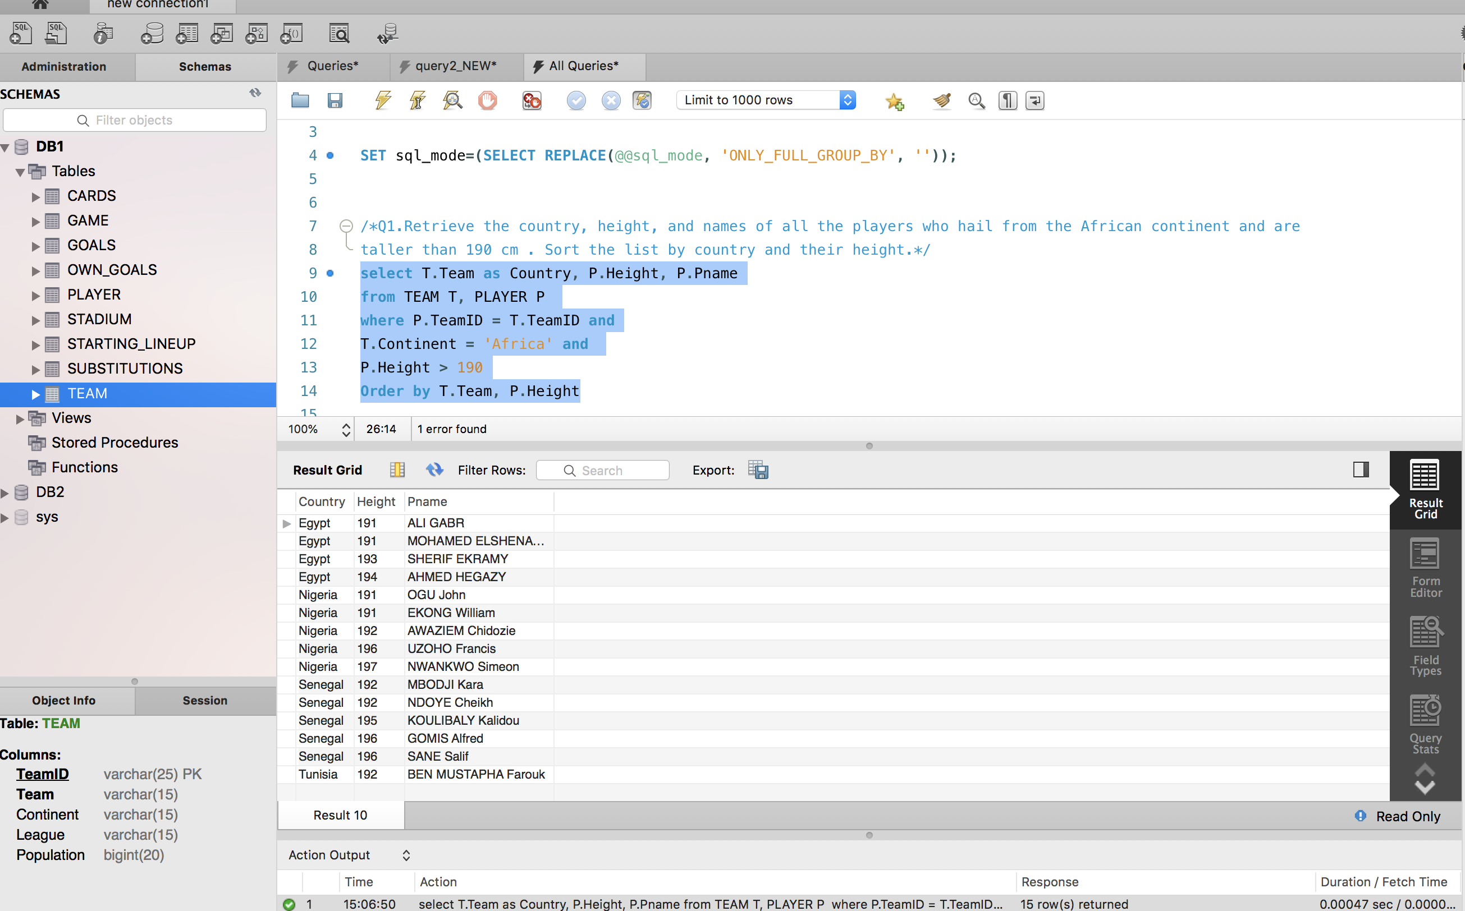

**Query 2:** Retrieve the scores of all games played in Group A or B where each team had at least one score. Each result should list team 1 name, team 1 score, team 2 name, and team 2 score. Sort the result by the match type.

**Solution: 5 rows returned**

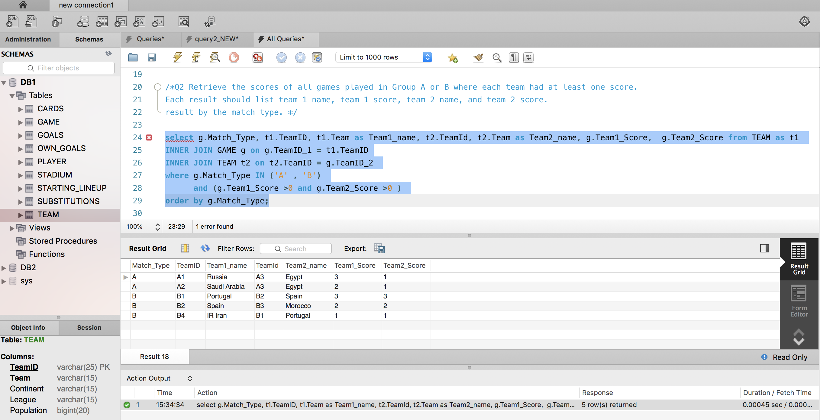

**Query 3:** For all the players who received red card, retrieve their country, player name, height and weight.

**Solution: 4 Rows Returned**

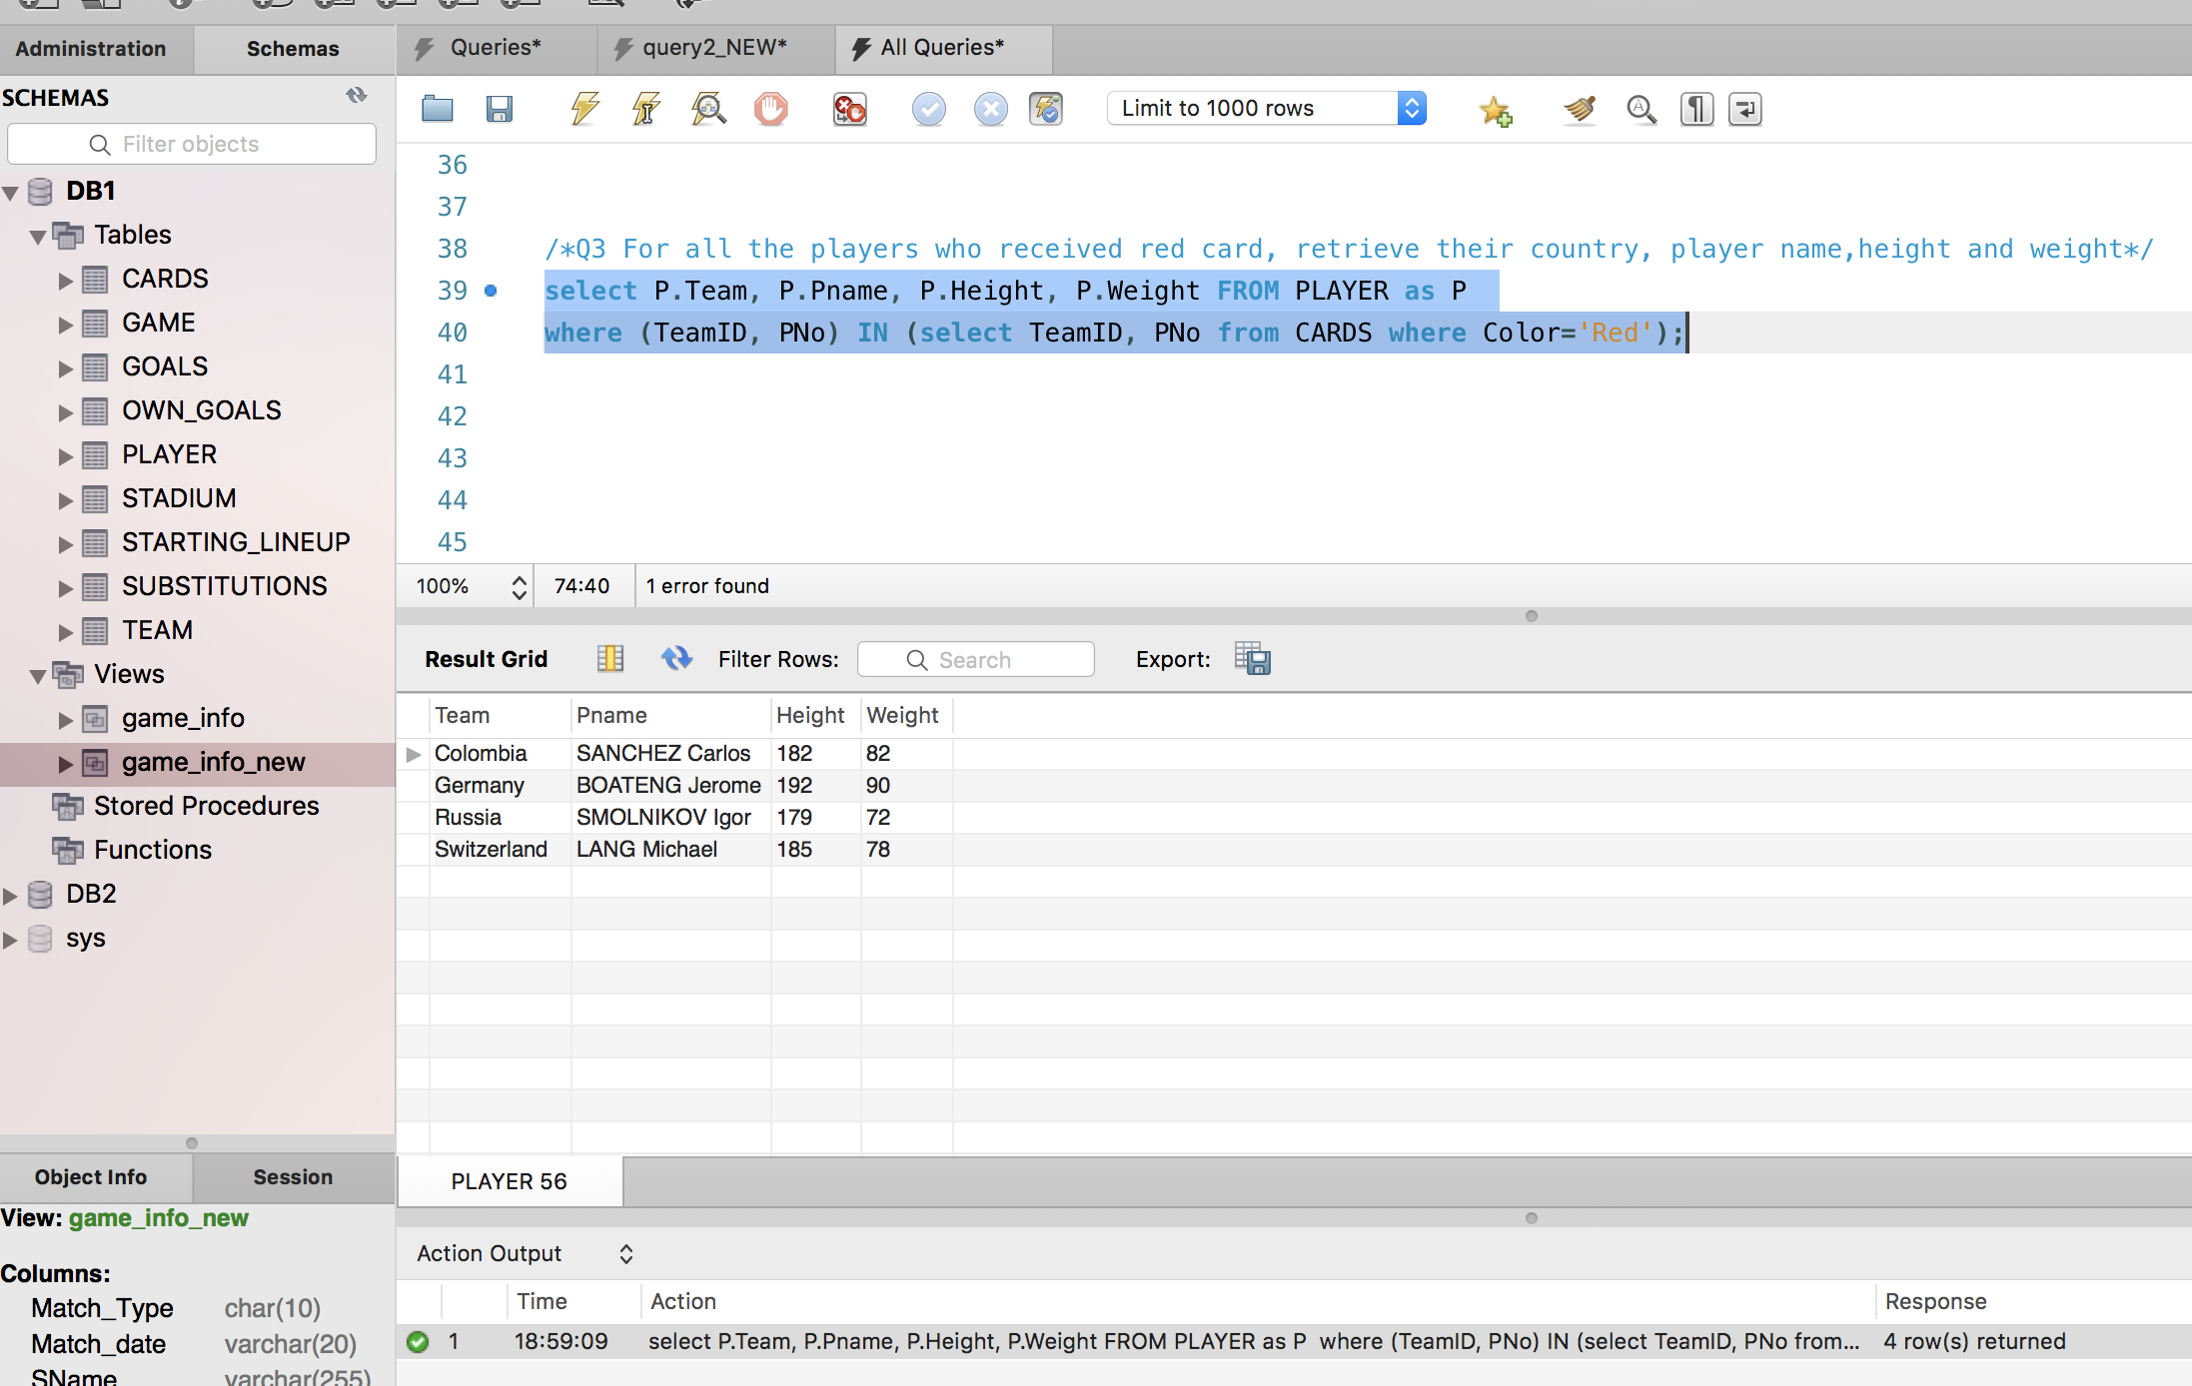

**Query 4:** What is the name of the player who received the maximum number of yellow cards? How many yellow cards did he receive, and which country does he come from?

**Solution: 1 Row Returned**

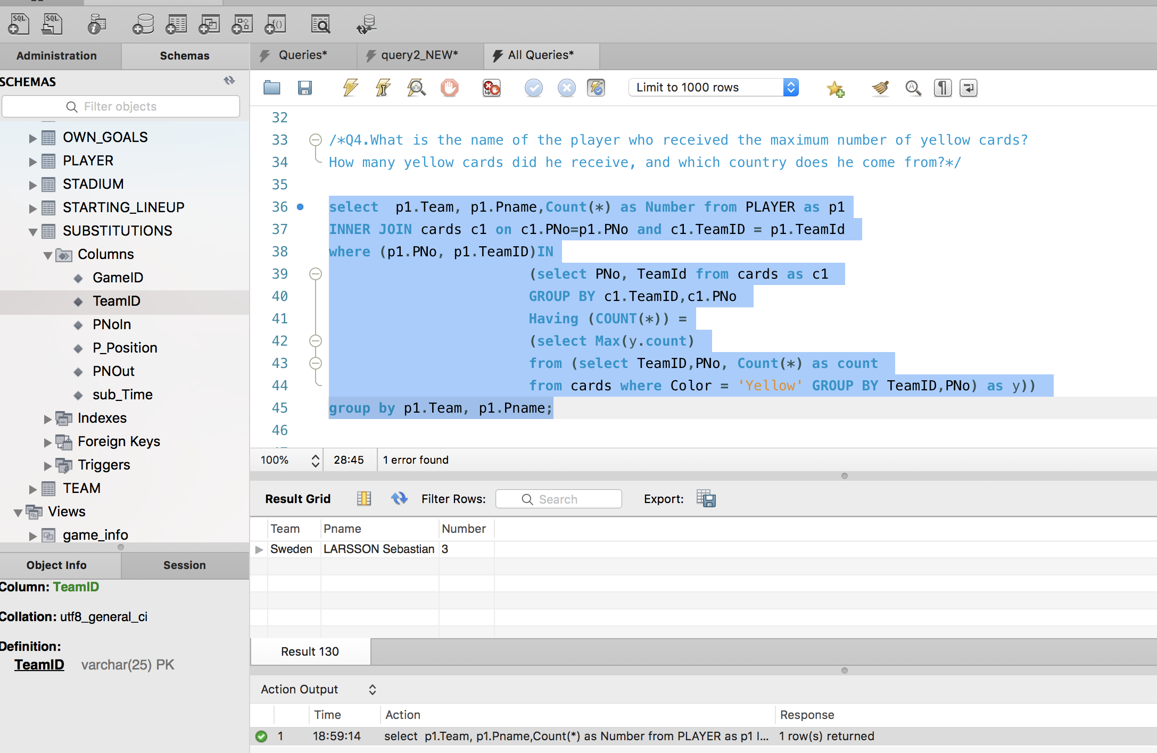

**Query 5:** Retrieve the names of the teams that scored more than 1 own goals in 1 or more games. List the number of own goals that each of these teams scored.

**Solution: 1 row returned**

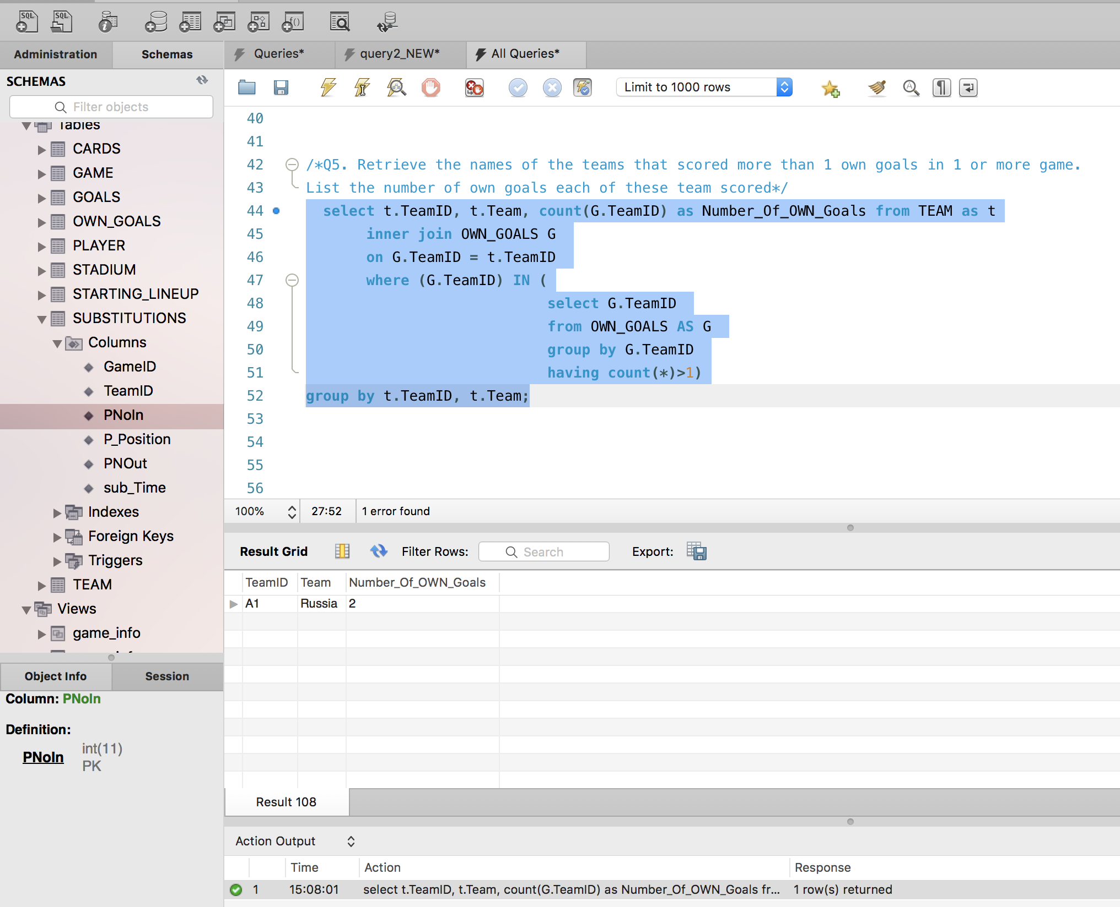

**KINDLY NOTE:**

**For Query No 6: We have come up with 2 solutions (A and B). Question says the view should have following attributes, Team and the information related to the, Team So we retrieve 128 records if we consider that. If we consider Team as Team1_name and Team2_name we get 64 records.**

**Query 6, Solution B returns exactly half the number of records (64), as compared to Solution A, which returns 128 records. (we have pasted both the solutions as suggested by the professor)**

**We have Performed all queries(4mentioned + 3additional) Queries, For both Solution A and Solution B**

**Query 6, SOLUTION A, returns 128 rows (Query 7a to 7d are based on Solution A):** Create a view **GAME_INFO** that retrieves for each team all that team’s game scores. The view should have the following attributes: Team, and for each game that the team has participated in (either as TeamID1 or TeamID2) the following information: Match Type, MatchDate, StadiumName, SCity, Team1Name, Team1Score, Team2Name, Team2Score.

**Solution:** **Created View GAME_INFO**

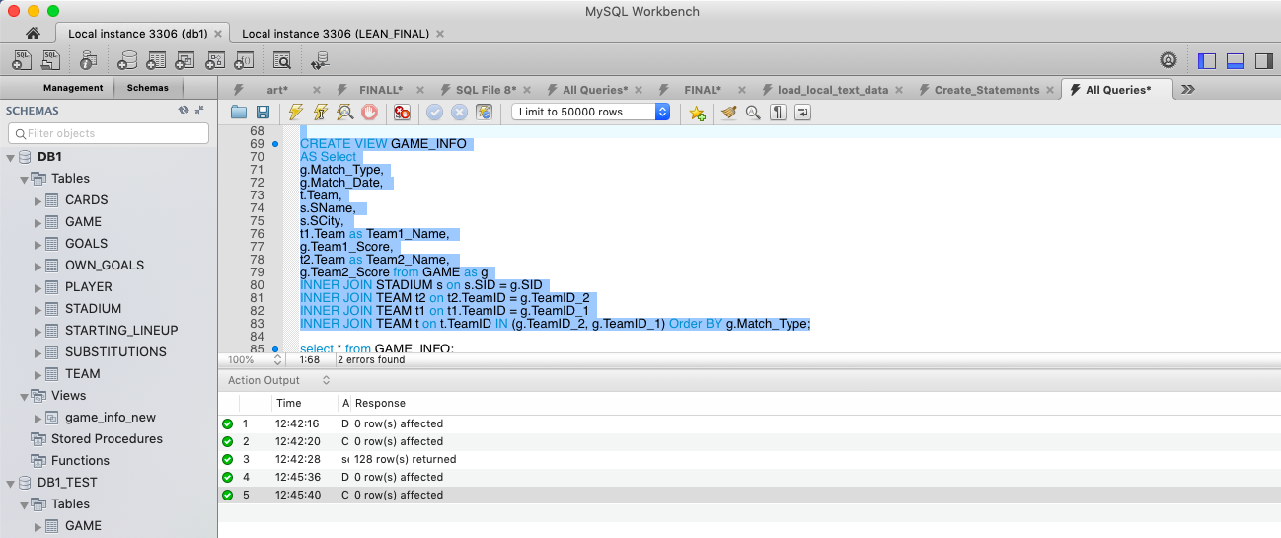

Return all Records from the Newly created View: **select * from GAME_INFO;**

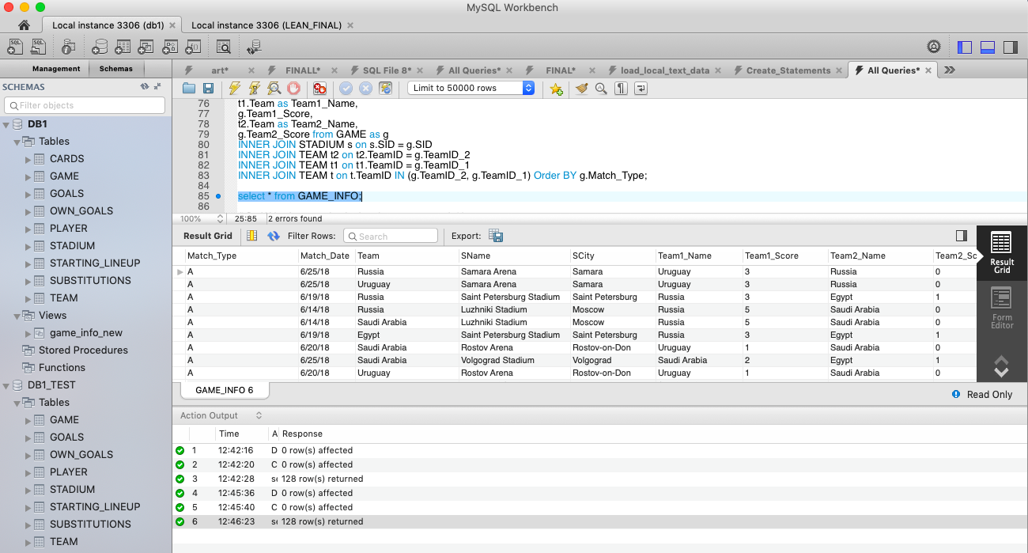

**Solution: 128 Rows Returned**

**Query 7: Write four queries in the view you created:**

**7a**. Retrieve all game information from GAME_INFO where France played.

**Solution**: Returned 7 rows

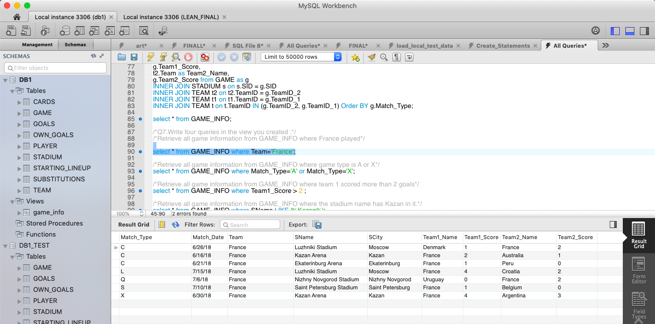

**7b:** Retrieve all game information from GAME_INFO where game type is A or X.

**Solution:** Returned 28rows

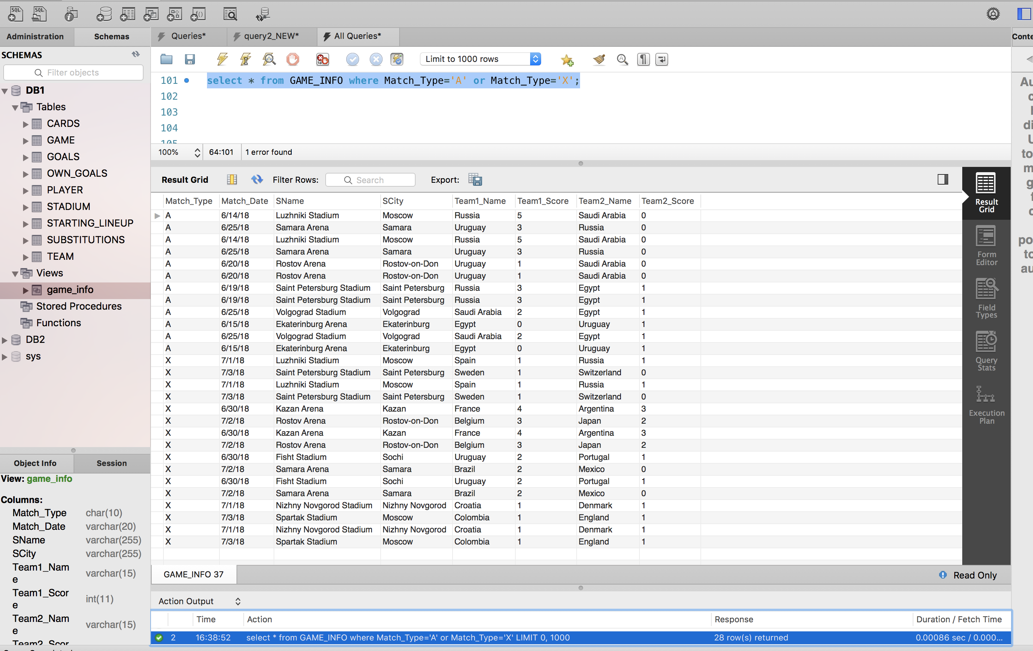

**7c.** Retrieve all game information from GAME_INFO where Team_1 scored more than 2 goals.

**Solution:** Returned 20 rows

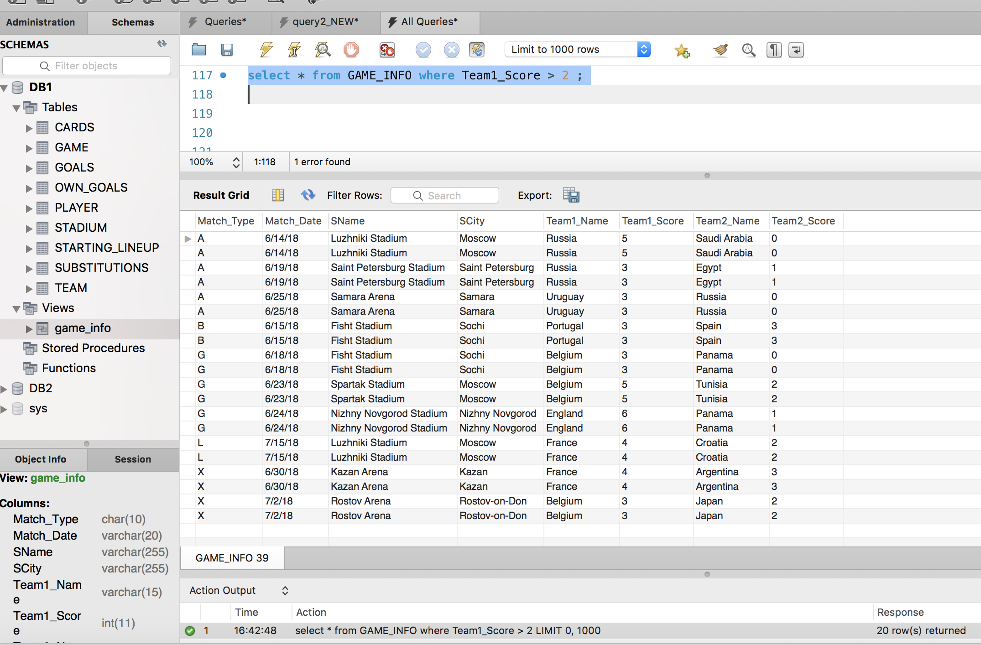

**7d:** Retrieve all game information from GAME_INFO where the stadium name has Kazan in it.

**Solution:** Returns 12 rows

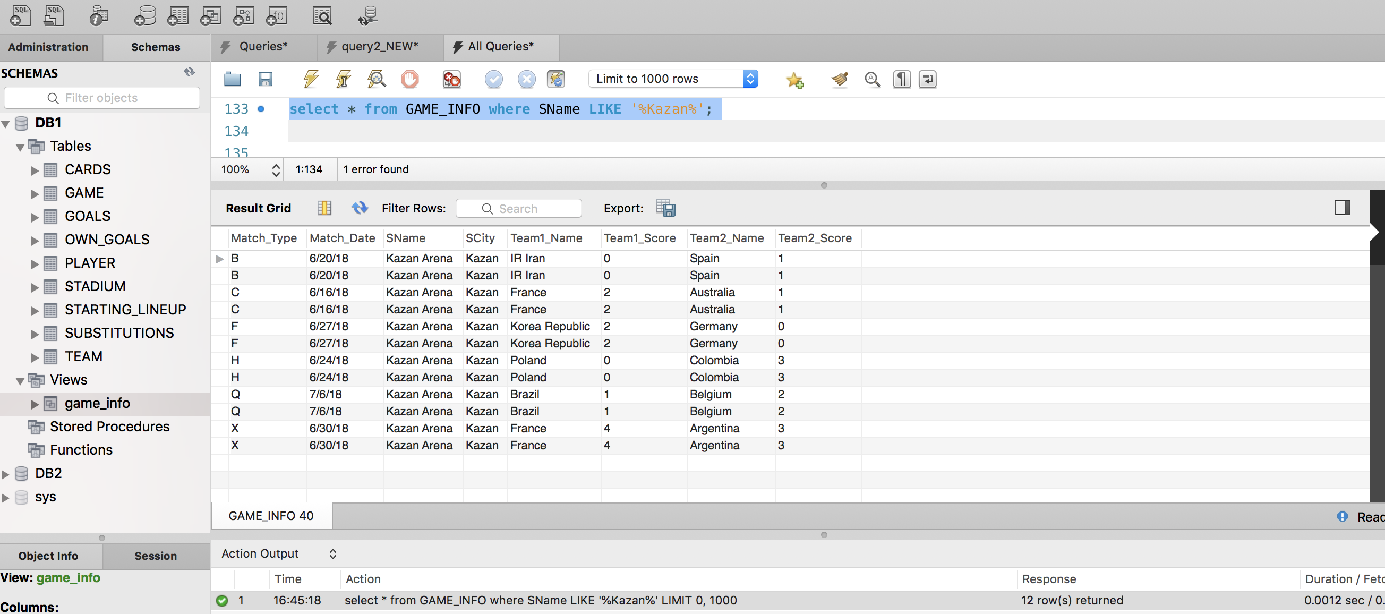

Write three additional queries on **GAME_INFO** and their results.

**Additional Query 1, for View GAME_INFO(Based on Query 6, Solution A):**

Retrieve all game information from GAME_INFO where Team “Morocco” was involved.

**Solution:** 6 rows returned

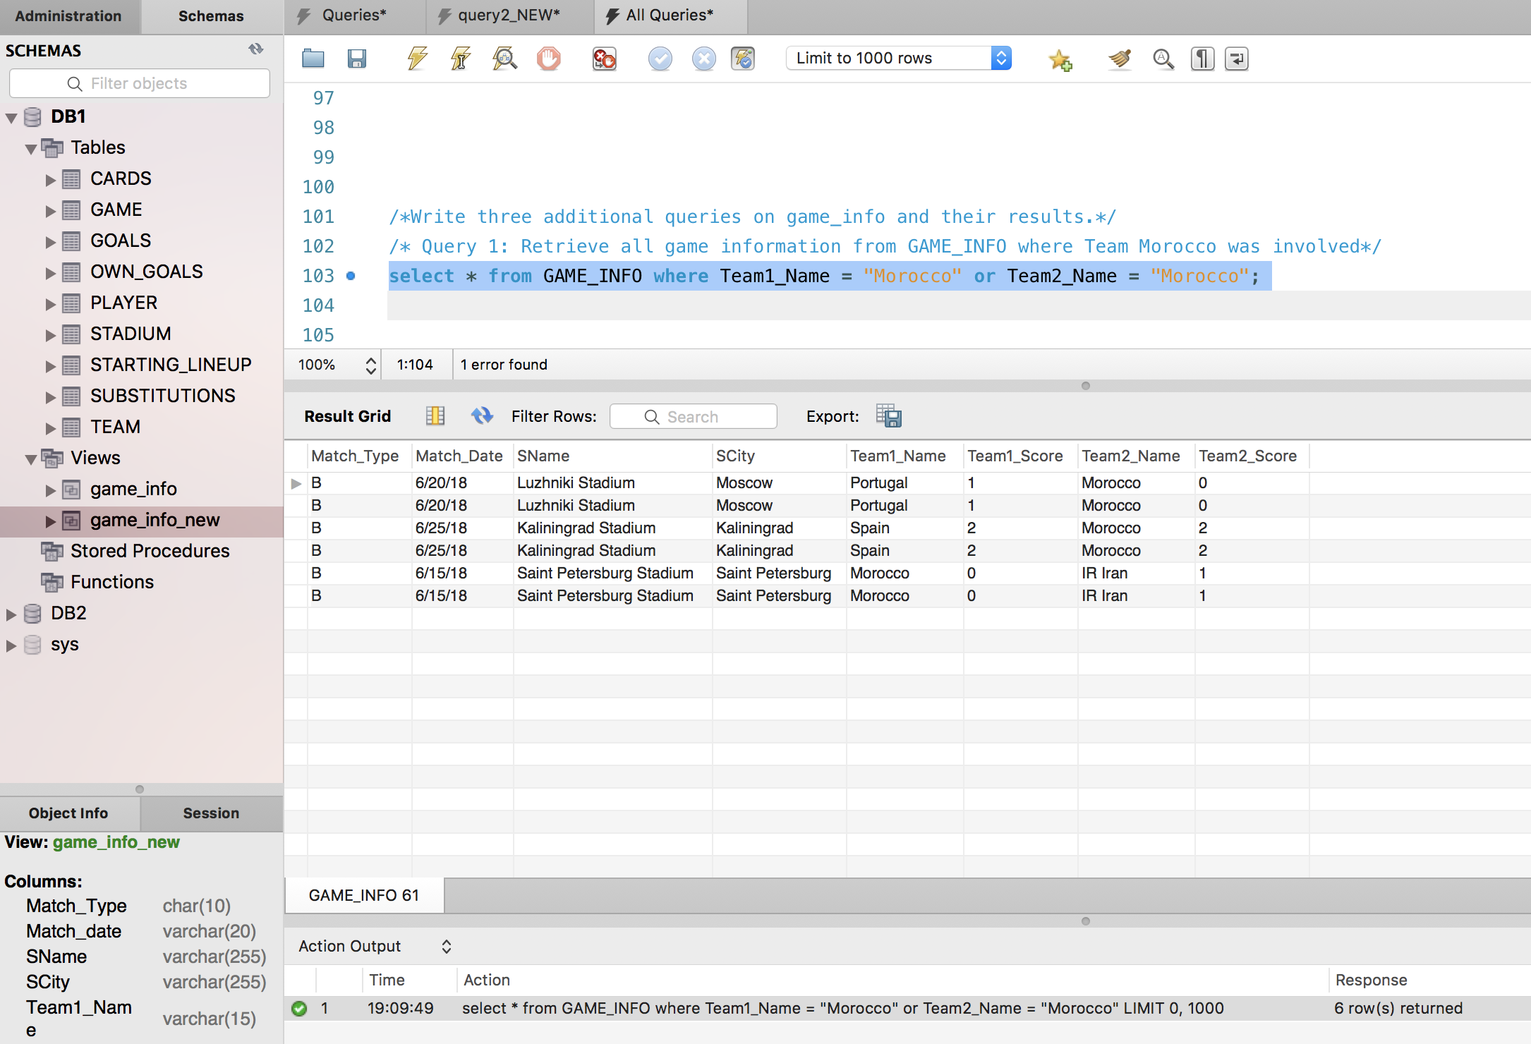

**Additional Query 2, for View GAME_INFO(Based on Query 6, Solution A):**

Retrieve all game information from GAME_INFO where matches were played between 20th June, 2018 and 25th June, 2018.

**Solution: 38 Rows Returned**

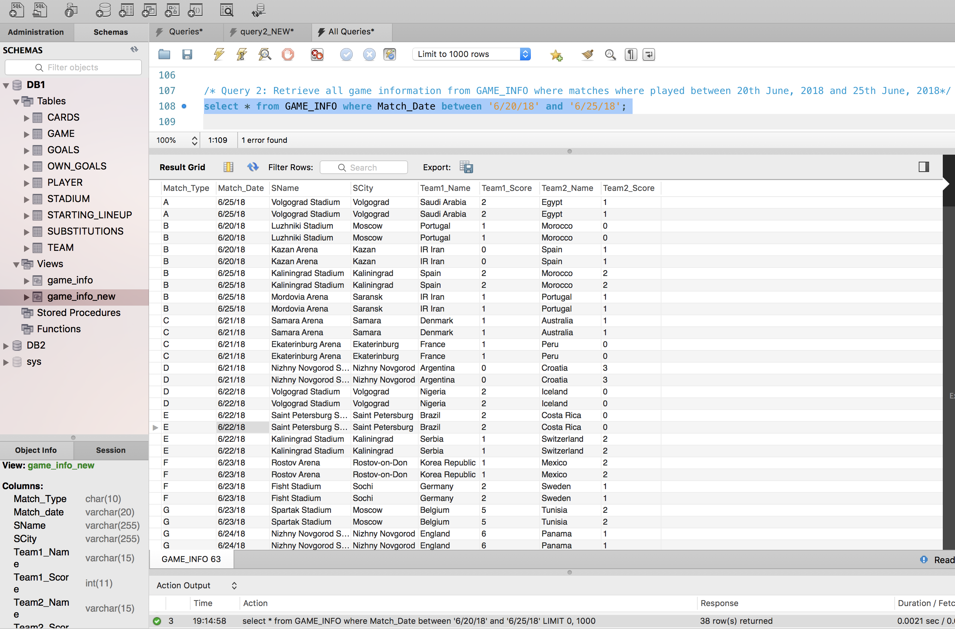

**Additional Query 3, for View GAME_INFO(Based on Query 6, Solution A):**

Retrieve all game information from GAME_INFO where Match C was played in either Samara Arena or Luzhniki Stadium

**Solution: Rows Returned 4**

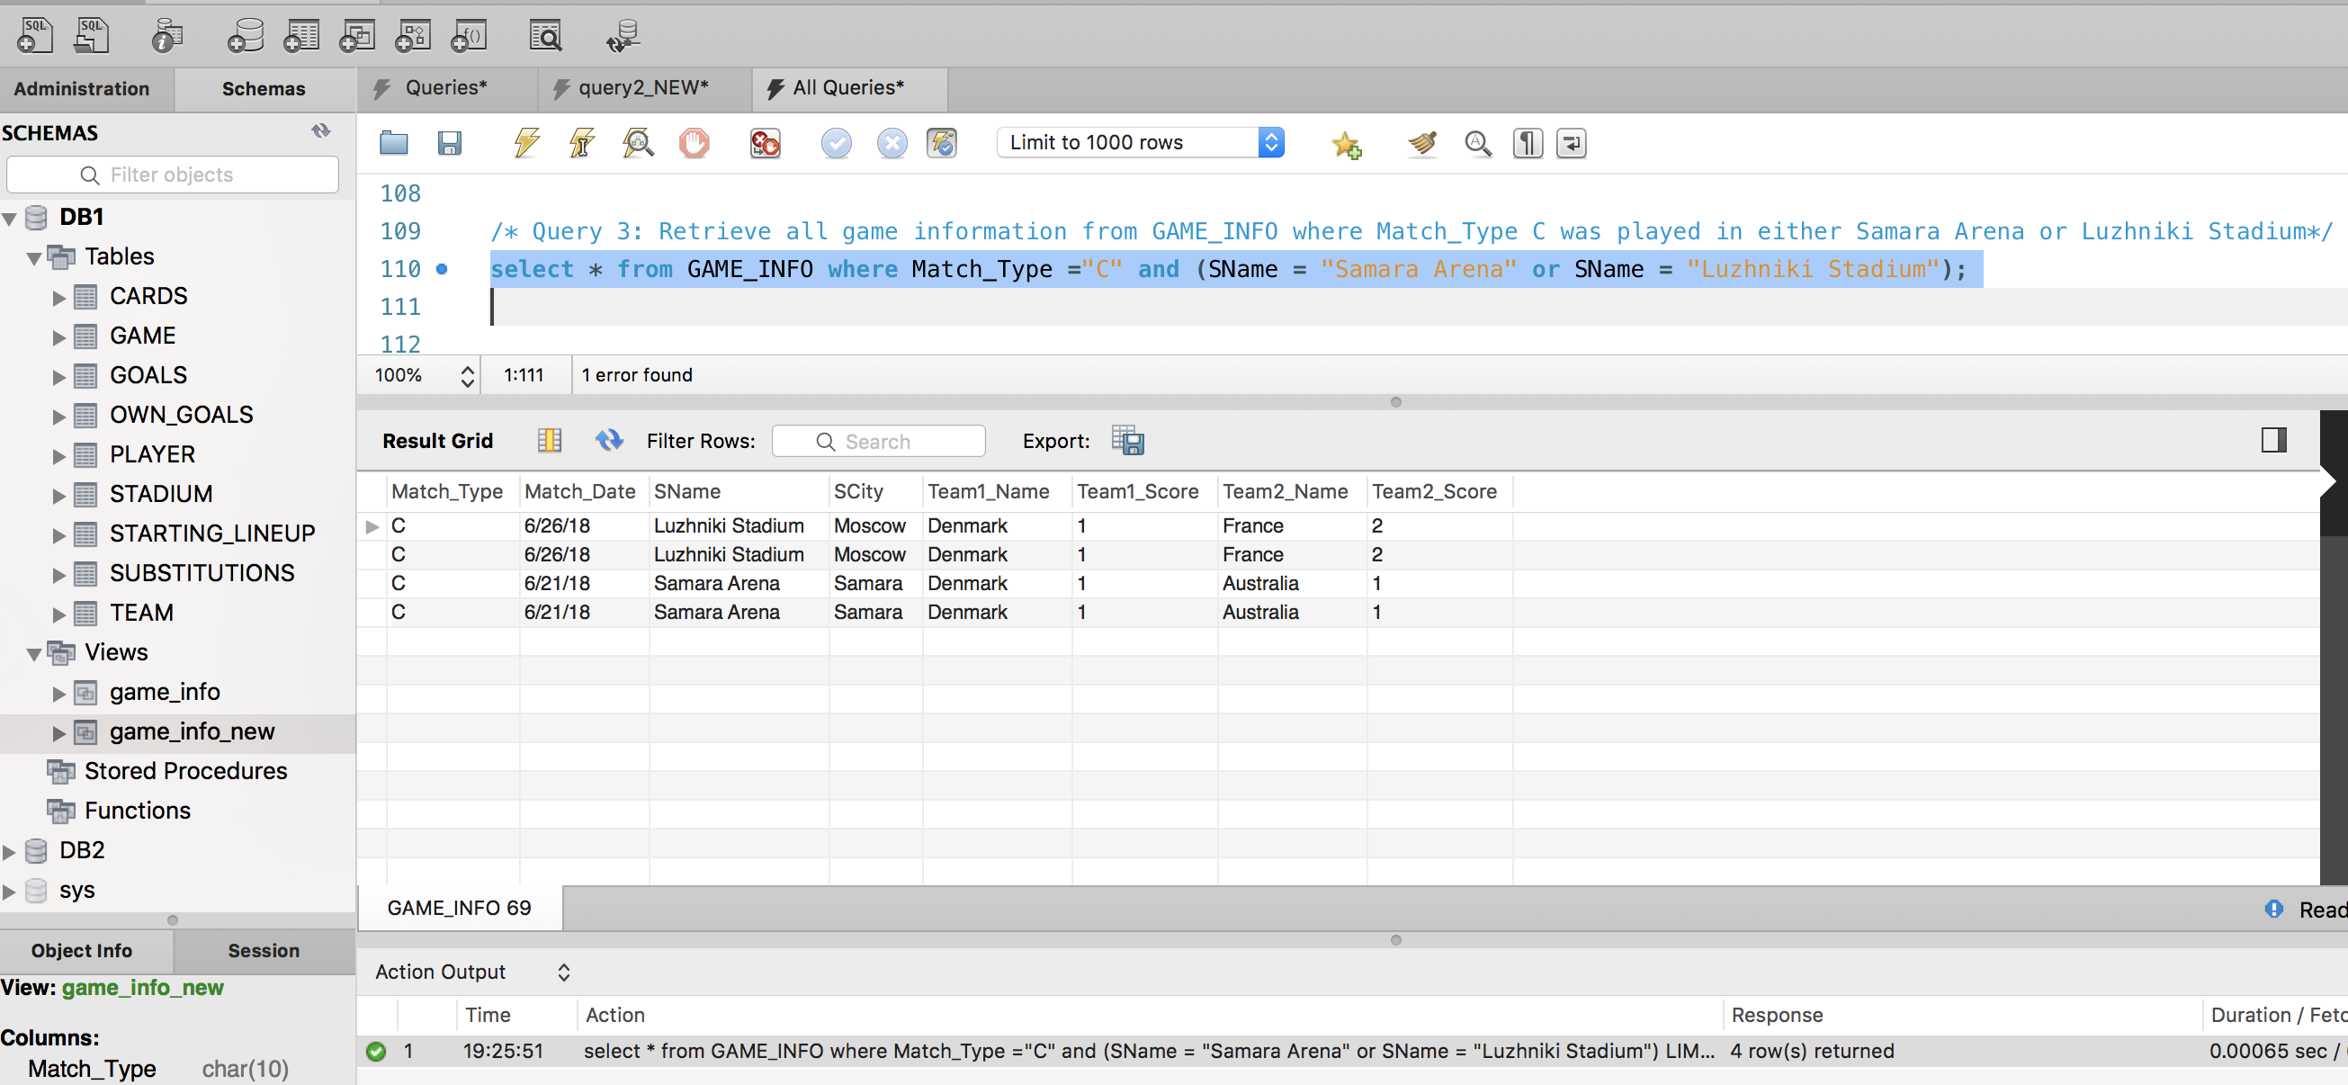

**Query 6, SOLUTION B, returns 64 rows (Query 7a to 7d below, are based on Solution B):** Create a view GAME_INFO_NEW that retrieves for each team all that team’s game scores. The view should have the following attributes: Team, and for each game that the team has participated in (either as TeamID1 or TeamID2) the following information: Match Type, MatchDate, StadiumName, SCity, Team1Name, Team1Score, Team2Name, Team2Score.

**Solution:** **Created View GAME_INFO_NEW**

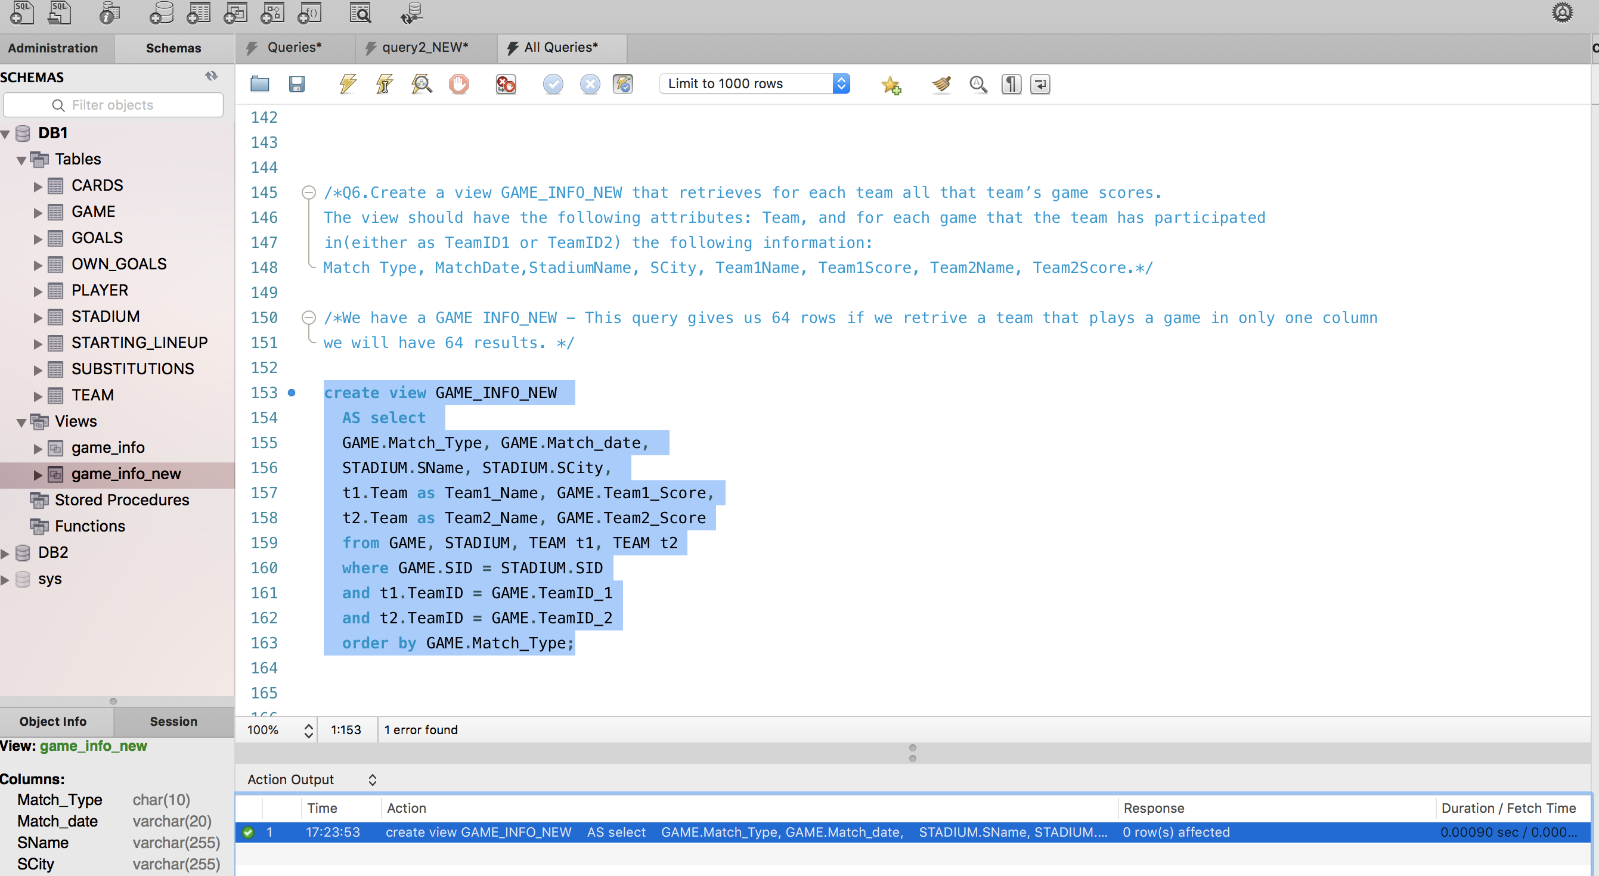

Return all Records from the Newly created View: **select * from GAME_INFO_NEW;**

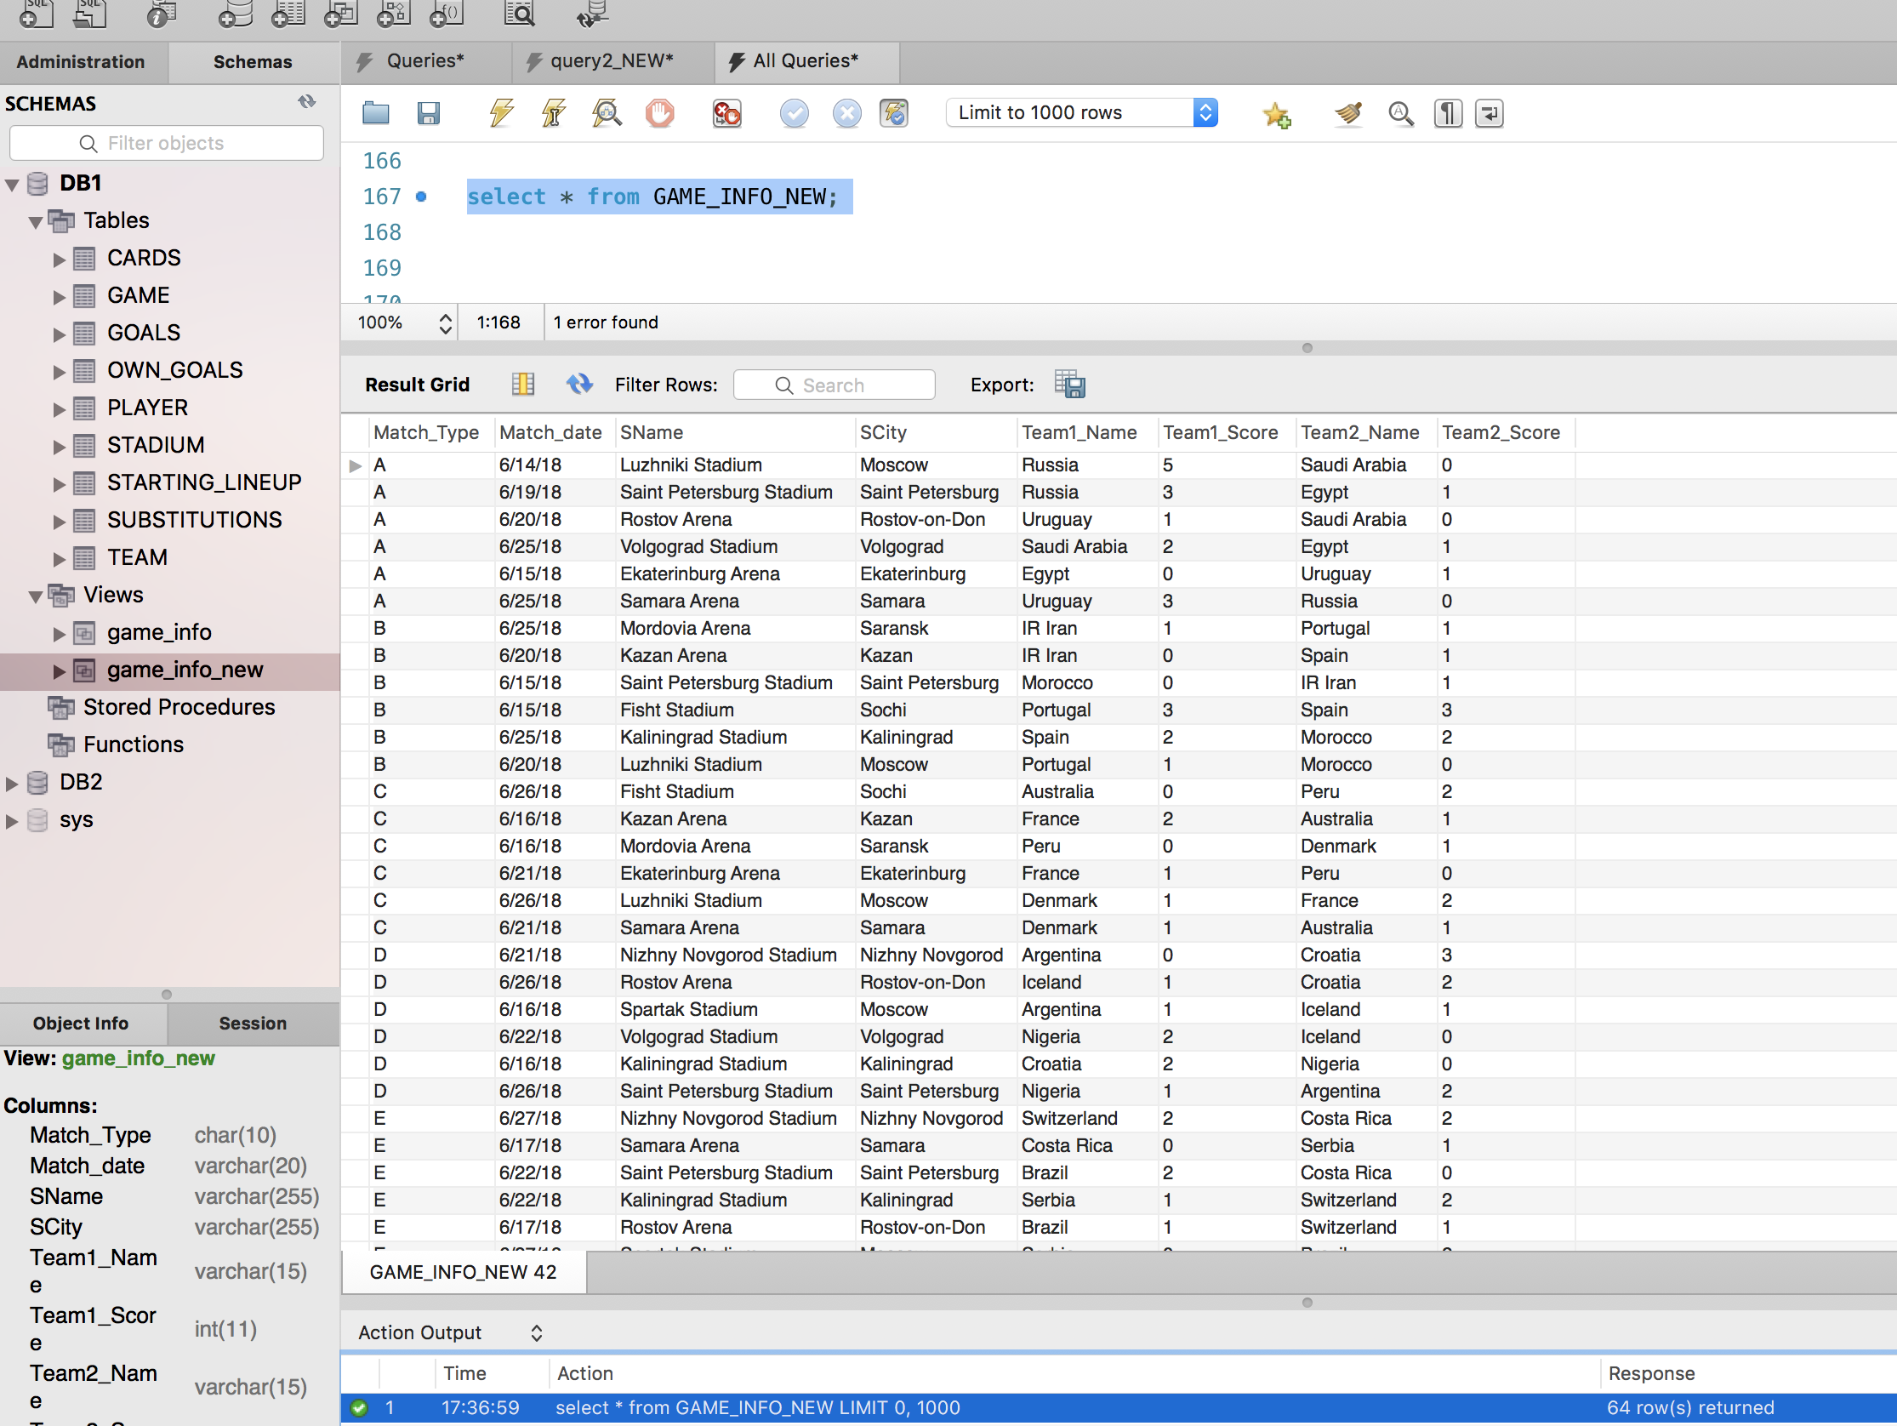

**Query 7: Write four queries in the view you created:**

**7a**. Retrieve all game information from GAME_INFO_NEW where France played.

**Solution: Returned 7 rows**

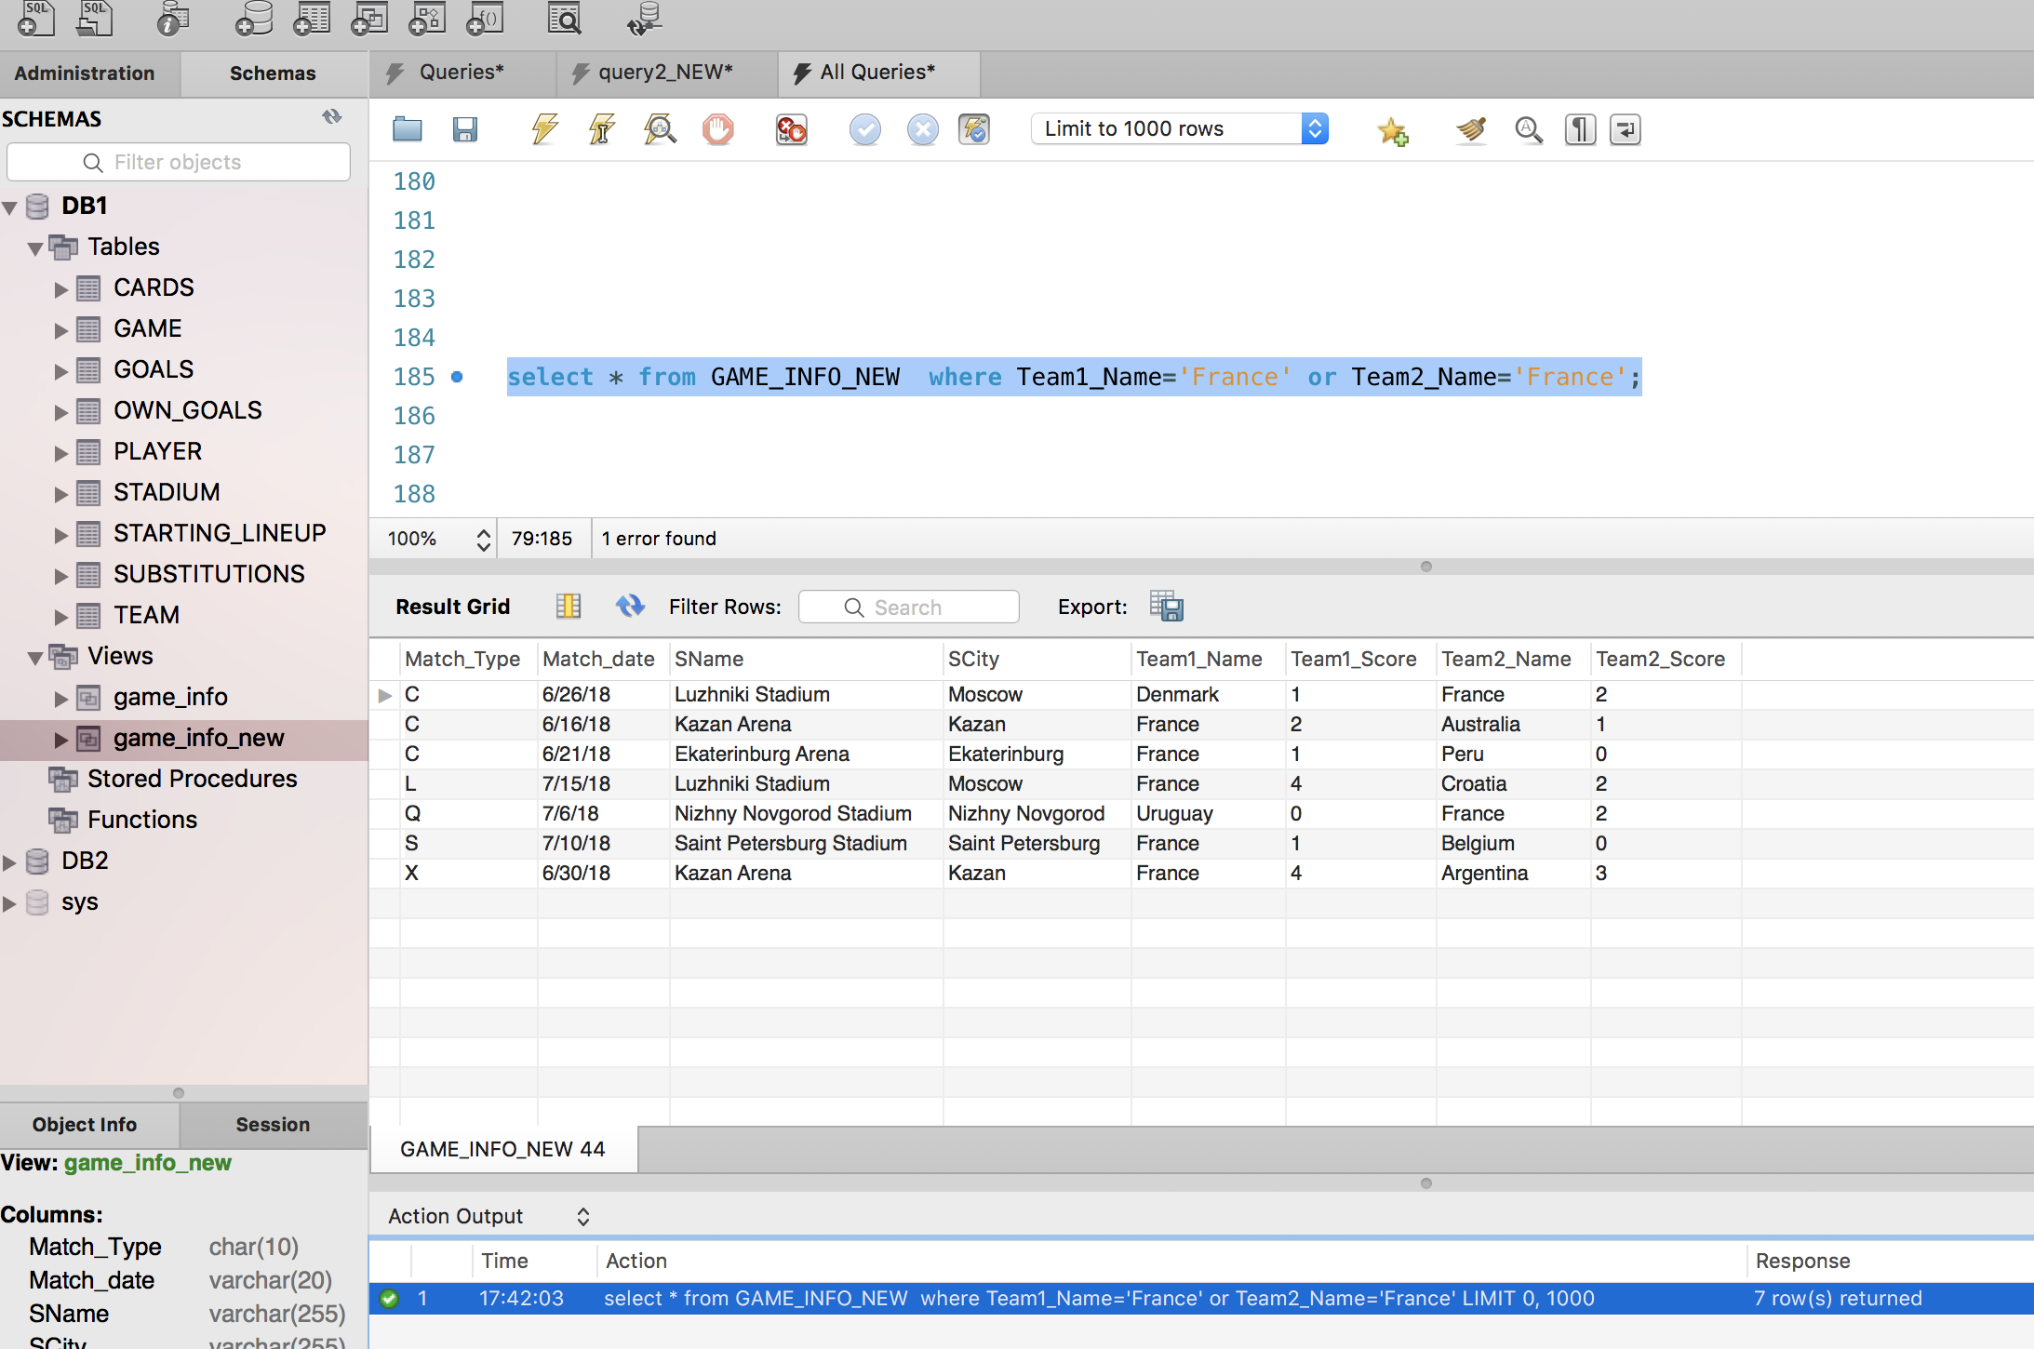

**7b:** Retrieve all game information from GAME_INFO_NEW where game type is A or X.

**Solution:** **Returned 14 rows**

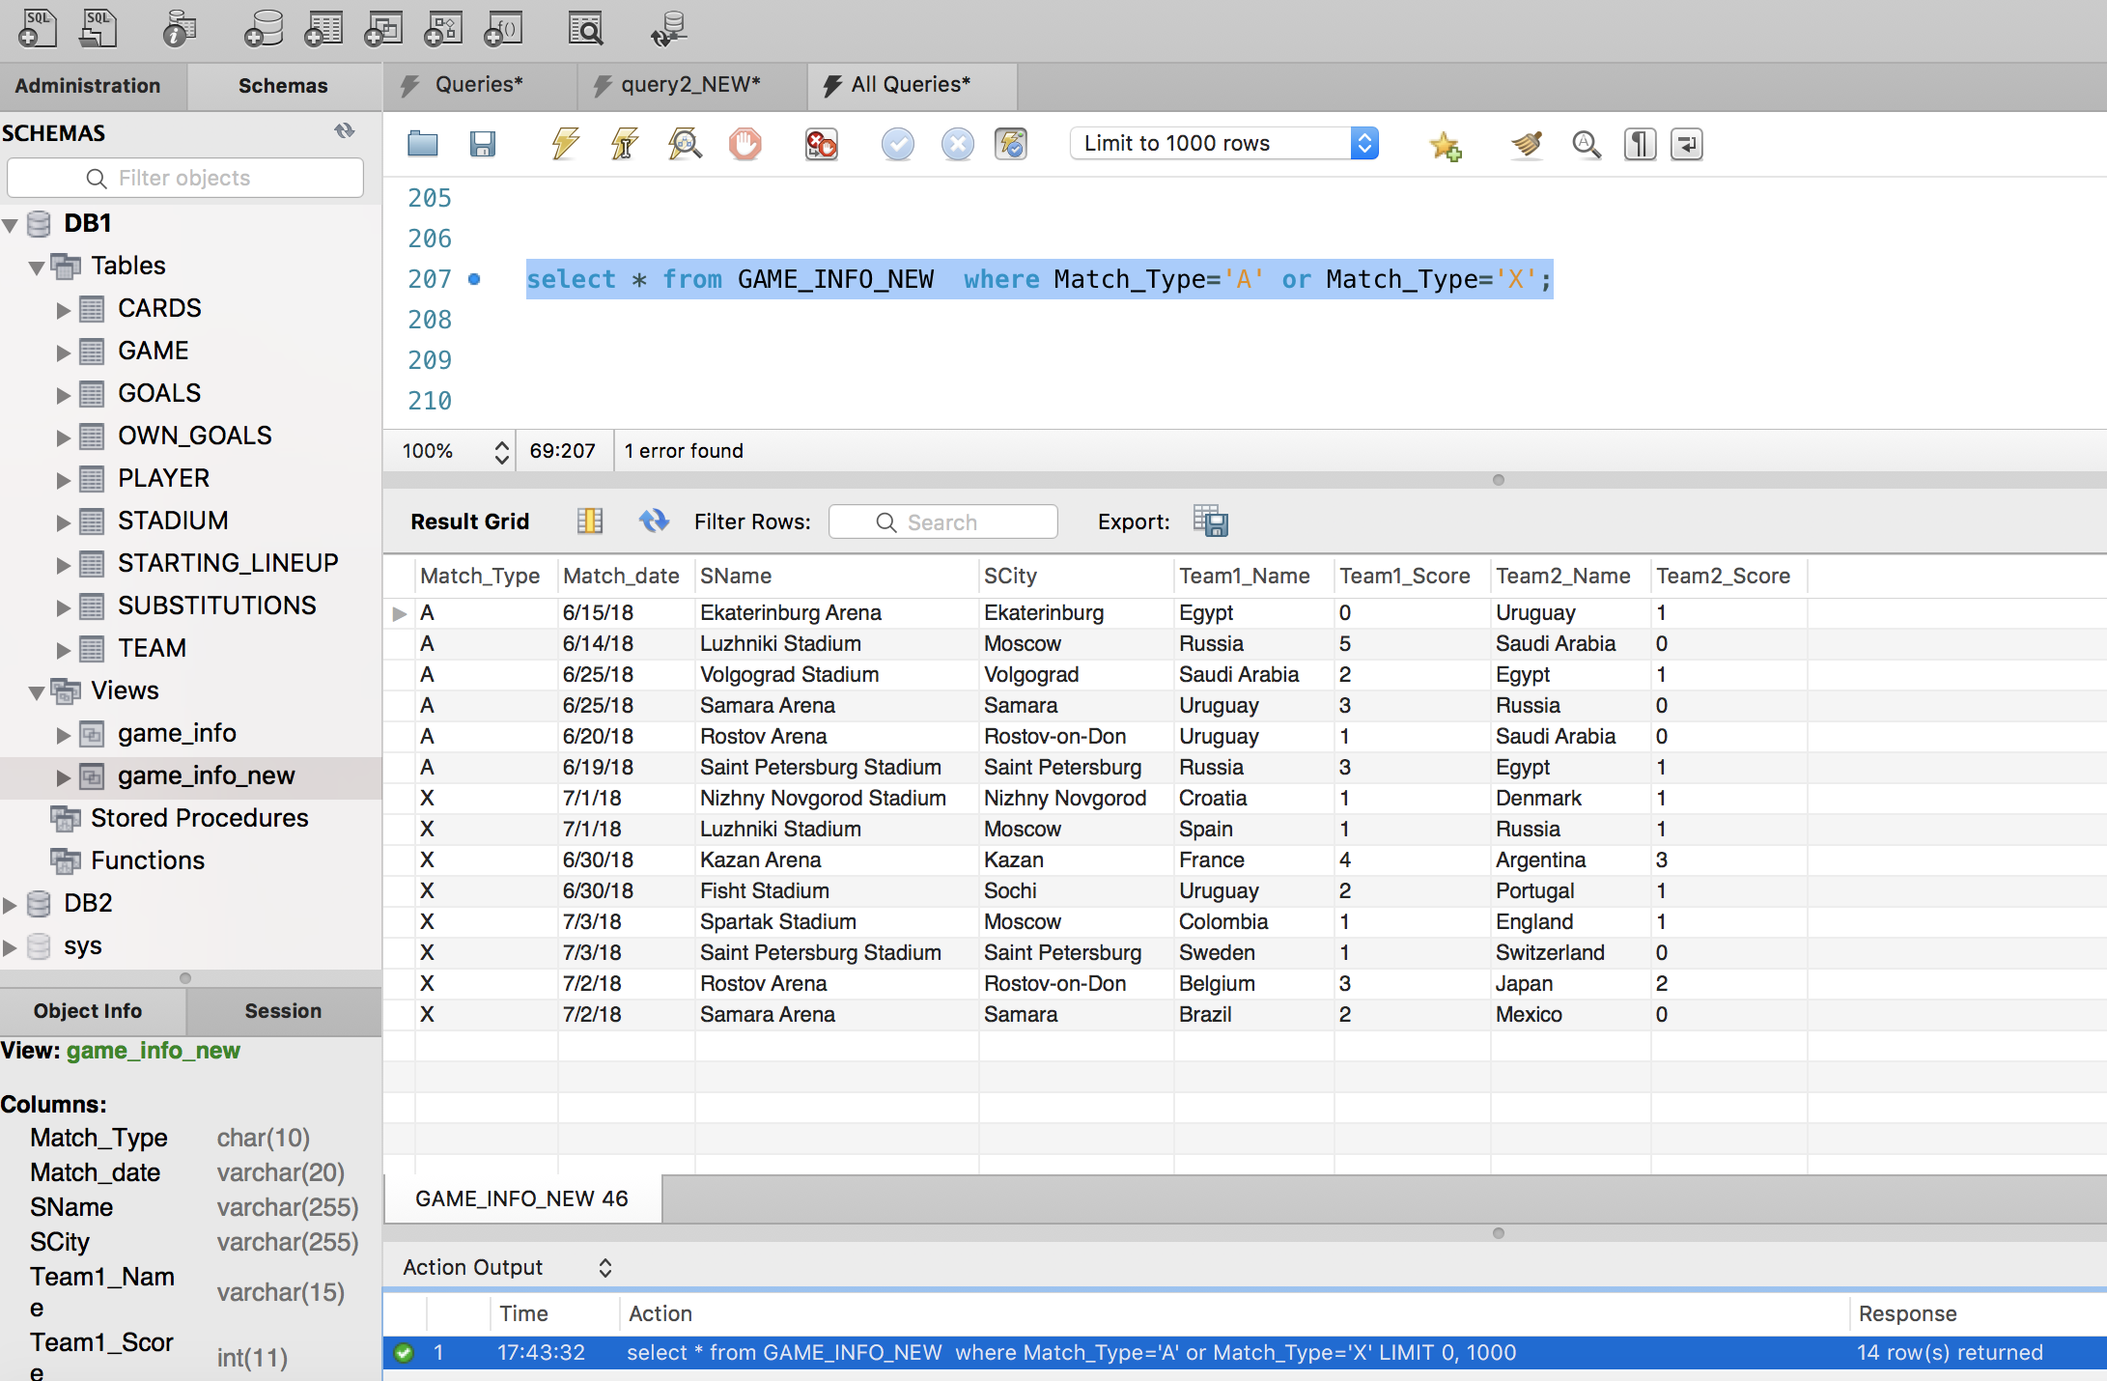

**7c.** Retrieve all game information from GAME_INFO_NEW where Team_1 scored more than 2 goals.

**Solution:** Returned 10 rows

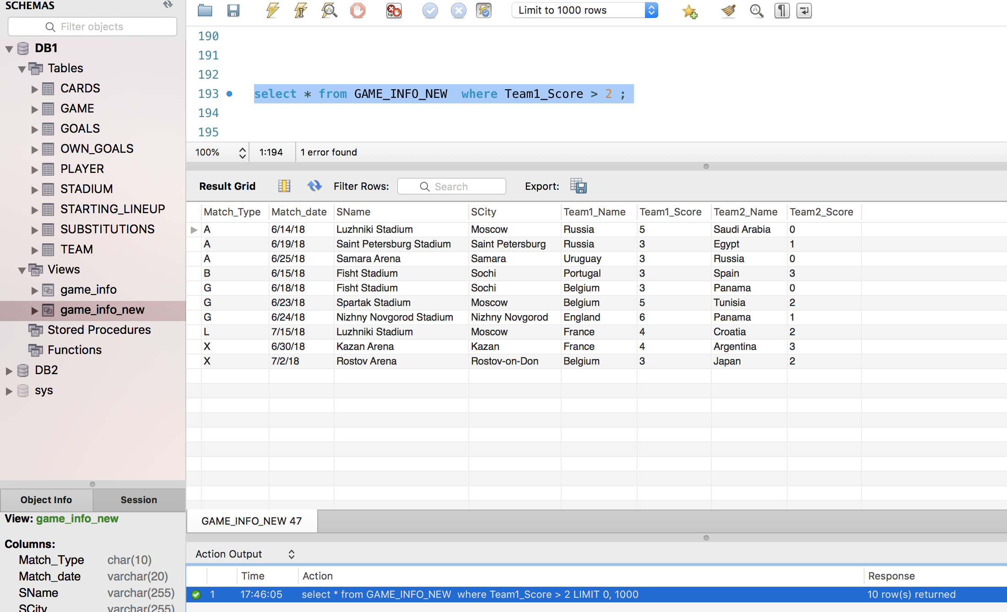

**7d:** Retrieve all game information from GAME_INFO_NEW where the stadium name has Kazan in it. **Solution:** Returns 6 rows

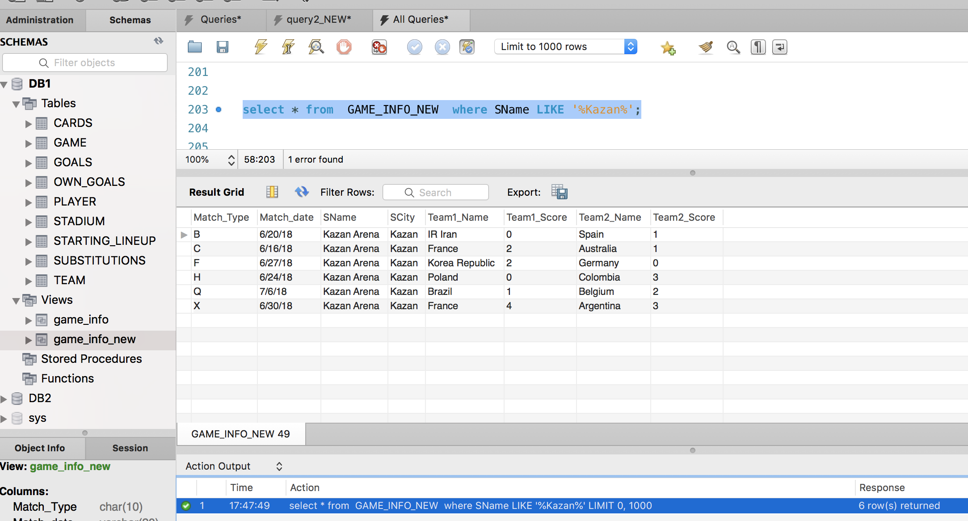

Write three additional queries on **GAME_INFO_NEW** and their results.

**Additional Query 1, for View GAME_INFO_NEW (Based on Query 6, Solution B):**

Retrieve all game information from GAME_INFO_NEW where Team “Morocco” was involved.

**Solution:** 3 rows returned

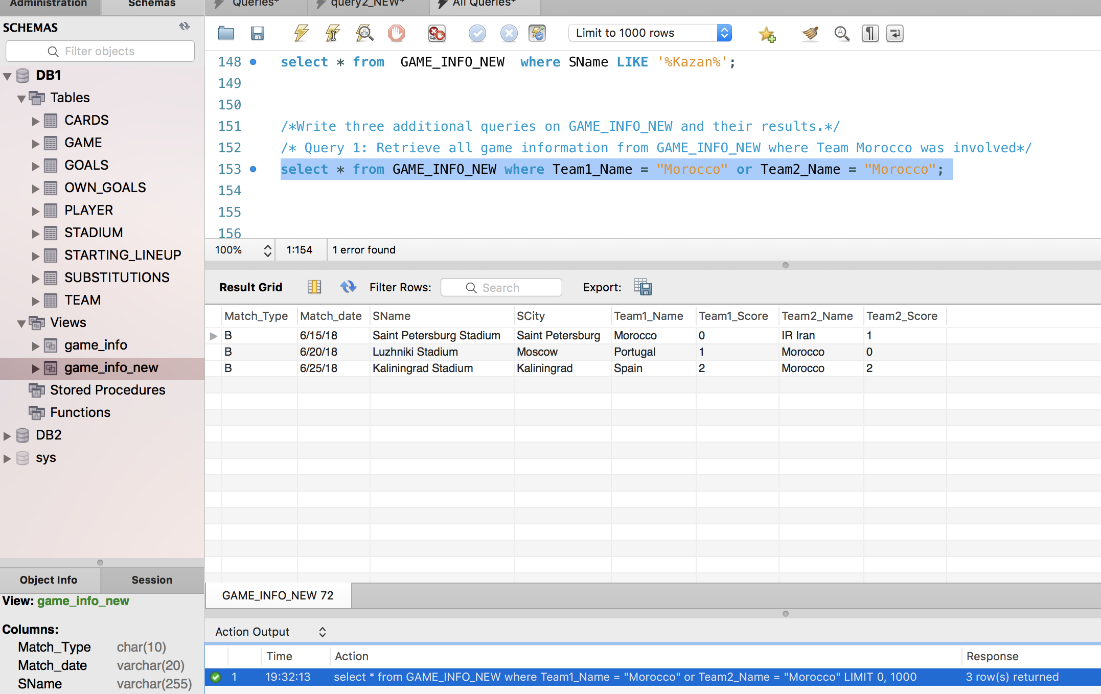

**Additional Query 2, for View GAME_INFO_NEW(Based on Query 6, Solution B):**

Retrieve all game information from GAME_INFO_NEW where matches were played between 20th June, 2018 and 25th June, 2018.

**Solution: 19 Rows Returned**

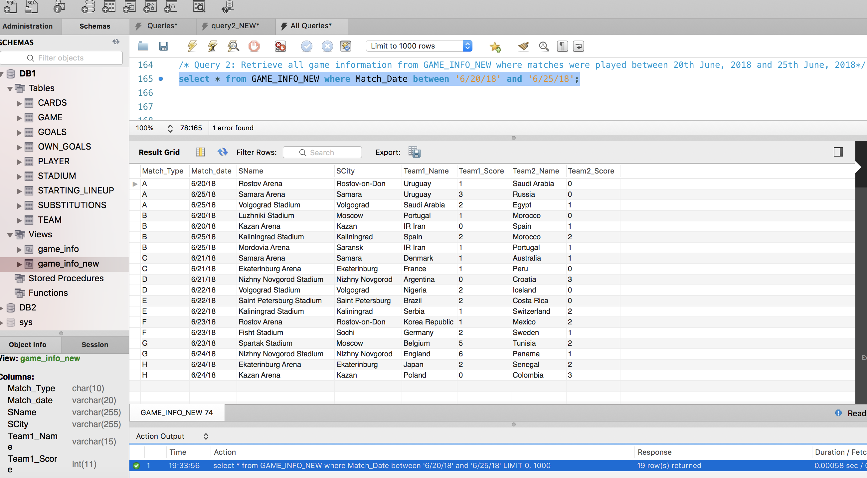

**Additional Query 3, for View GAME_INFO_NEW(Based on Query 6, Solution B):**

Retrieve all game information from GAME_INFO-NEW where Match C was played in either Samara Arena or Luzhniki Stadium

**Solution: 2 Rows Returned**

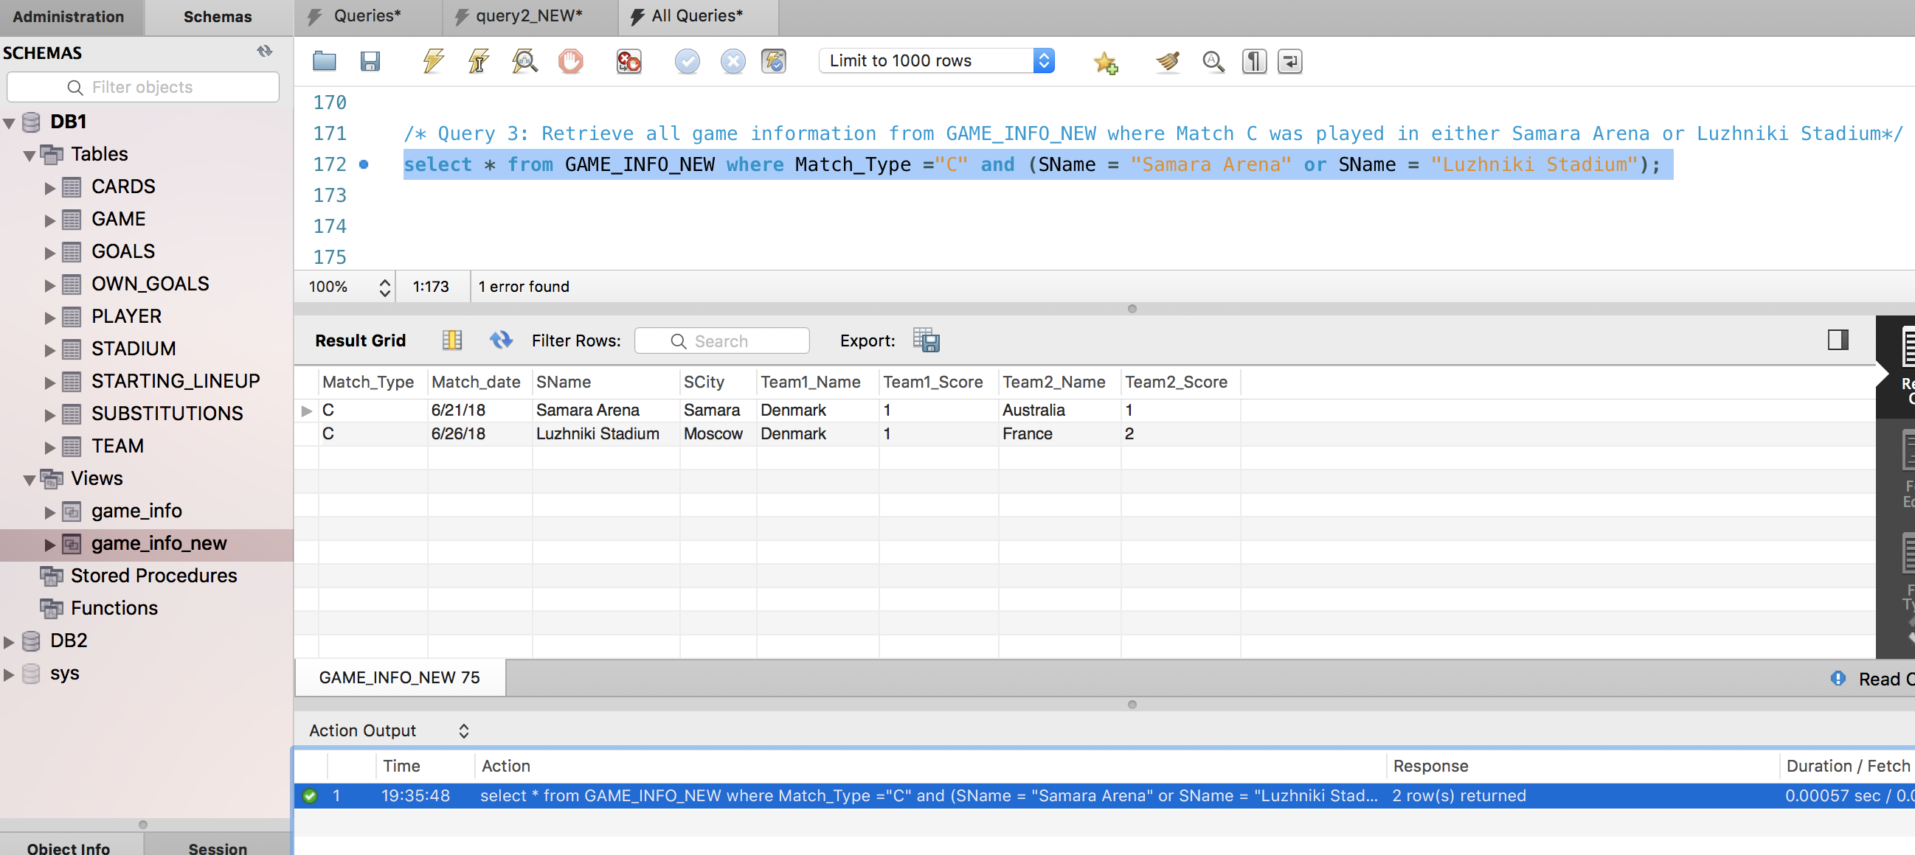

**Query 8(i):** Retrieve the name of the player and his country who received a yellow card

during A game. Sort the list by country names.

**Solution: Returns 11 rows**

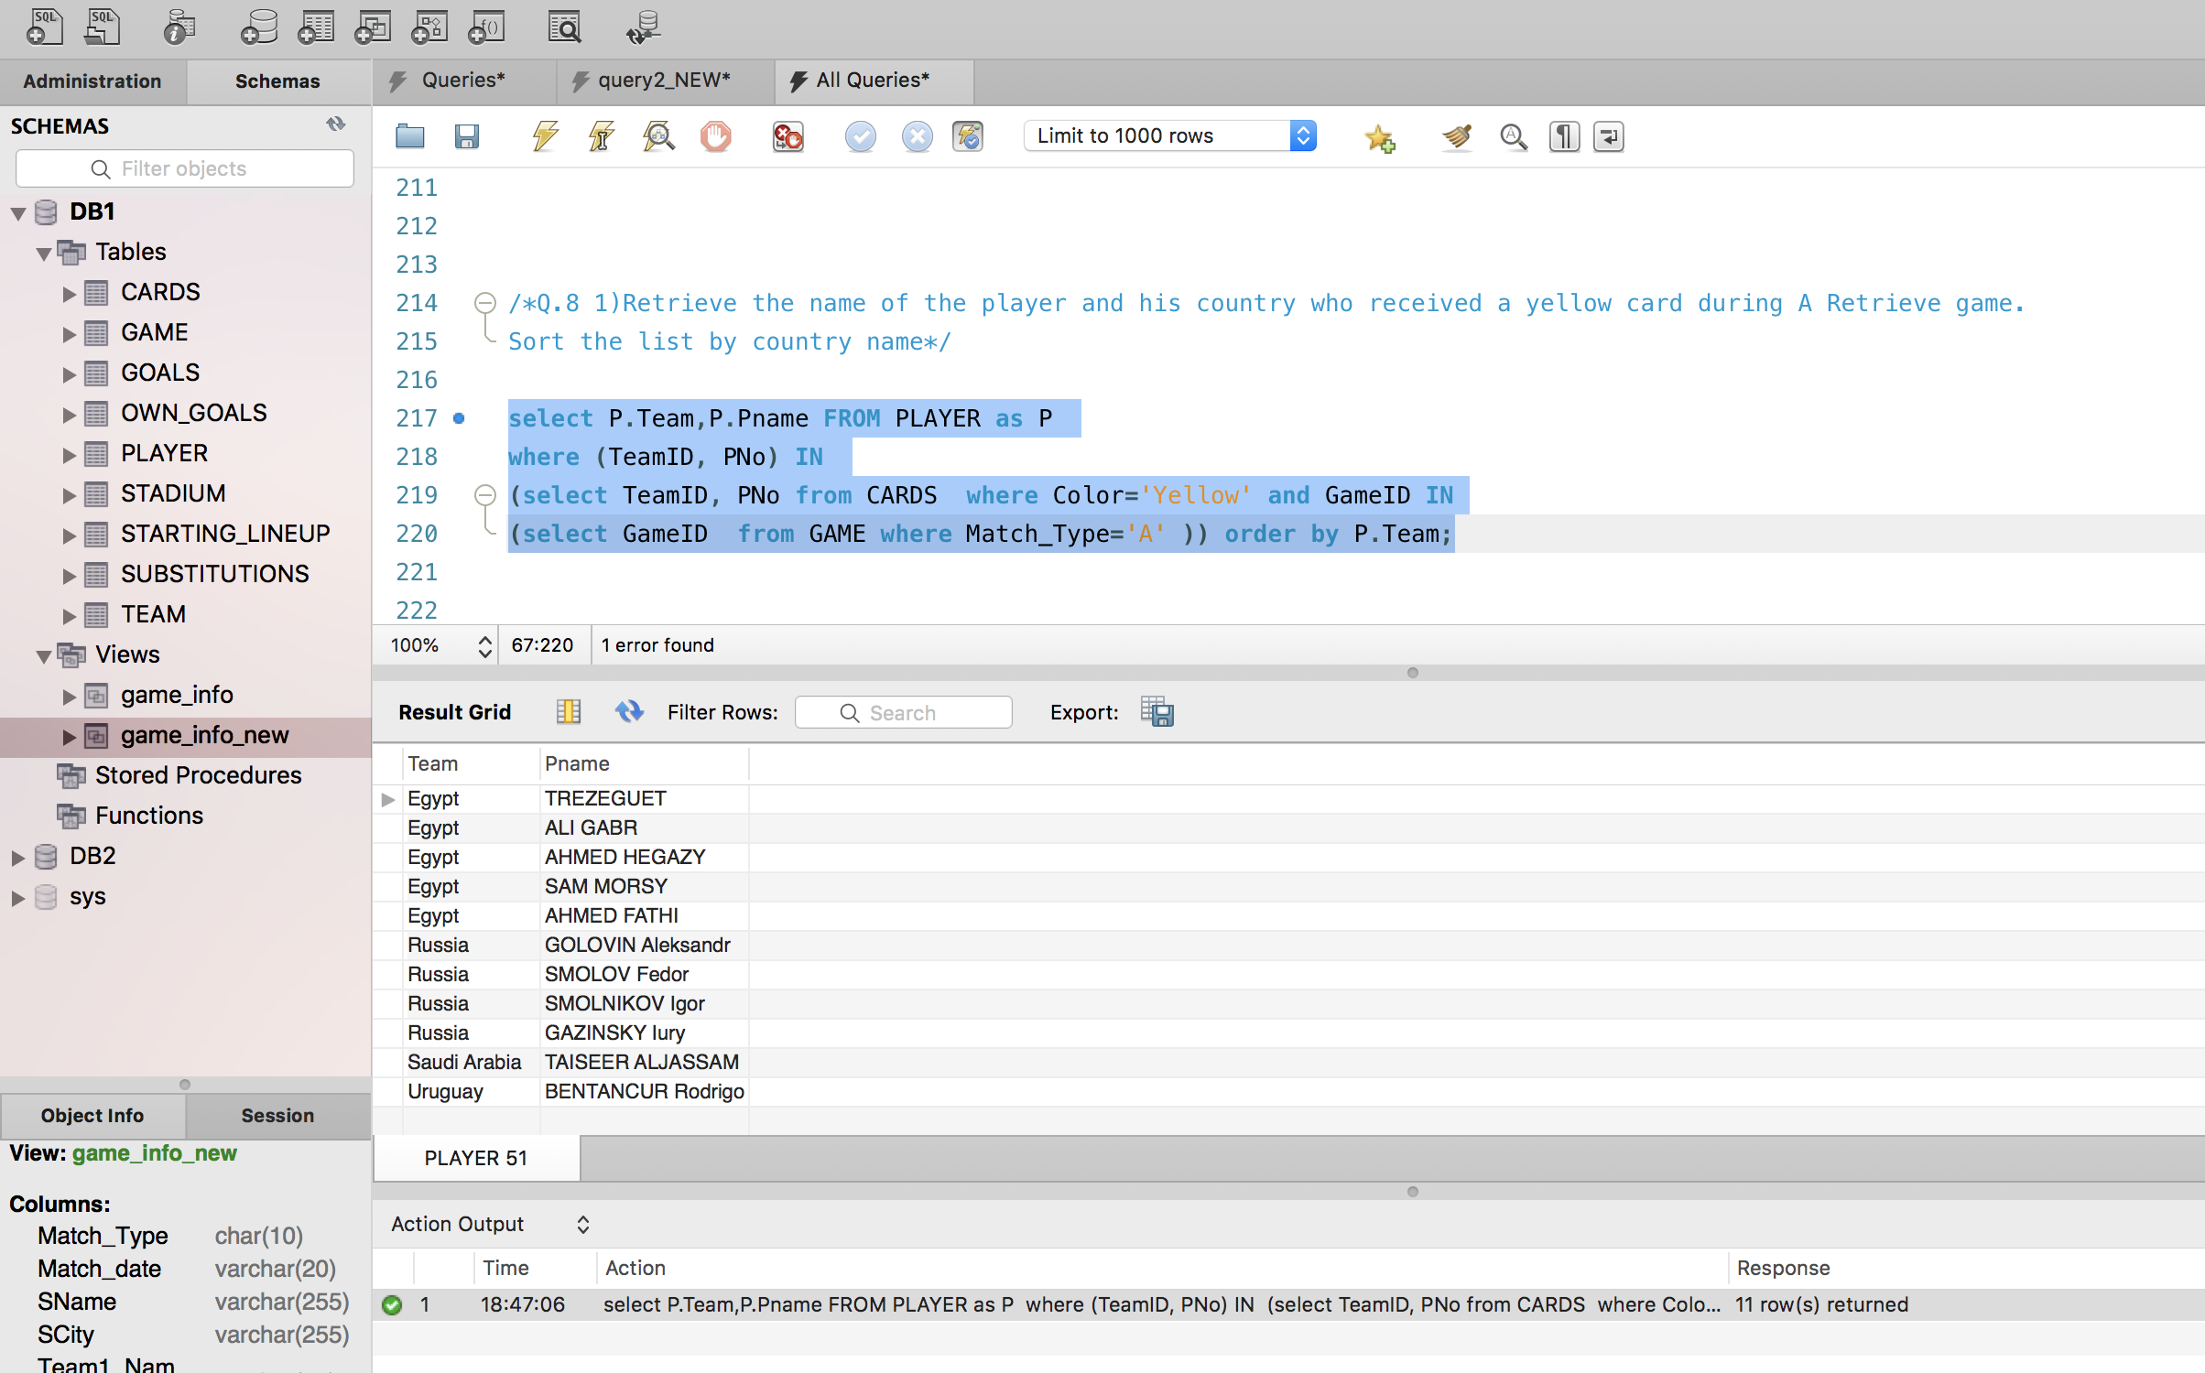

**Query 8(ii):** Retrieve a sorted list of the names of each country/team that played at Least one game In the city of Sochi.

**Solution: Returns 11 rows**

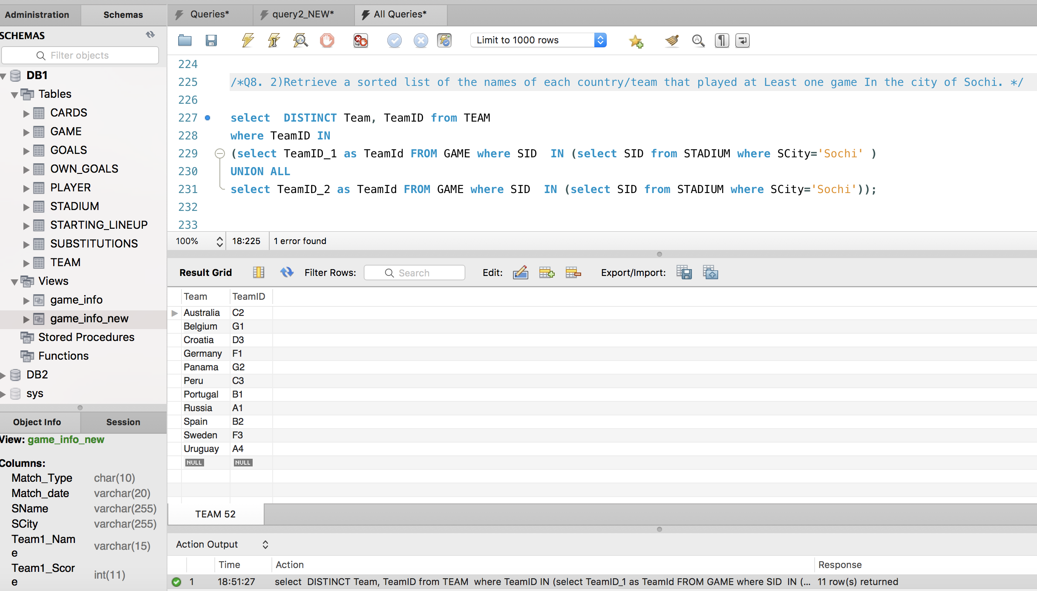

**Query 8(iii):** For each player who was substituted in the first 30 minutes of a game, retrieve the player name (PlayerOut) and the substitute player’s name (PlayerIn), and the minute of the substitution, as well as the team name.

**Solution: 5 Rows Returned**

